Back of House Cat Comforting: Beyond Blue Dot
Today’s Training:
- The Areas in Back of House(BOH)?
- General information
- Order of visitation
- The difficult side of BOH comforting
- Important signs, stickers and cage identifiers

The Areas in Back of House

The Wiggle Room (6 cages):
- Most often infectious skin issues, but….
- Occasionally other medical issues: broken limbs, wounds, cats under treatment for a variety of issues such as UTI’s, renal issues, diarrhea, dental issues… it’s a catch all
- When space is an issue in observation, there may be bite cases, as well

The Nursery (12 cages):
- Kittens awaiting foster
- Feral kittens under behavior treatment. Feline Behavior Specialist can help with information on how to work with these guys.
- Nursing moms with kittens
- Cats in the process of giving birth
- Pregnant cats awaiting foster
- Be aware of how mom is acting
- Most everyone is headed to foster
- Can house URI and other medical concerns. Pay attention to all signs and stickers.

Observation (18 cages):
- Non-infectious medical issues: broken limbs, wounds, cats under treatment for a variety of issues such as UTI’s, renal issues, diarrhea, dental issues… it’s a catch all
- Safe harbor cats
- FeLV cats awaiting medical clearance to move to our admin area
- Bite case cats
- Cats under behavior treatment
- Some stray holding, when there’s space

Isolation (10 cages):
- Almost exclusively cats undergoing treatment for upper respiratory infections
- Some other infectious (to other cats) respiratory issues
- Sometimes there will be cats being treated concurrently for URI and other issues, URI is the prevalent issue in iso
- Both kittens and adults are housed here

General Information:

What Can I Expect?

- All normal hand sanitizing/ towel use rules still apply
- BOH has a different cleaning time than FOH. In general, comforting is after 1pm, seven days a week but you’ll need to be flexible
- Staff may be in and out of the room while you’re comforting... It can be busy in BOH

- Injuries and illnesses can be difficult to see
- Very fearful or unhappy cats
- You’ll often be comforting alone in the room that you’re in, minimal contact with other comforters while you’re in BOH
- Not all cats will make it to the adoption floor, it can be quite sad at times
- Deeply rewarding. These are our most at risk cats and you’re helping them on the “front line”.

Reminders:

- Sign up in VIC in advance for our own hours
- Communicate with other BOH comforters, if there’s more than one person at the same time volunteering
- Document interactions with the cats on the observation logs in each room
- Go slower, be more aware of everything you see and do while visiting with the cats
- There’s a code to unlock the door to BOH by the laundry room, take towels and a hamper back with you when head back
- Use the medical alert board in BOH just as you would with the one in FOH
- Please don’t interfere with medical or shelter staff as they work in these rooms
- Make sure the door to the room that you’re in is always closed when you’re comforting
- Interact with the cat from outside of the cage prior to going into the cage. Soft eyes and a sideways approach really goes a long way with these cats.
- Read all posted signs on the cage as well as any notes written on the cage card before entering the cage

- Move slowly and with care when not in the cage, as well
- Quiet is key while visiting in these rooms
- Singing and talking to the cat in a gentle voice is a good approach
- Allow cats to hide as needed, we don’t ever push these cats. Let them direct the visit.

Just a Few Pointers:

- Don’t add food to the cat’s cages
- Don’t scoop litter. You may sometimes see black pellet litter in their litterbox, this is used to collect urine when needed.
- Length of visit is really based on how the cat responds. Some may only want five minutes, some may not want you to leave. The FOH visitation rules don’t necessarily apply here.
- Use your instinct, it’s ok to have a talk only visit or no visit at all if that’s what the cat is telling you they need
- If a cat gets loose, quietly leave the room and find a staff member
- For procedural questions, check with the Behavior Manager. For cat behavior questions, see the Cat Behavior Specialist. For general volunteer questions, please see the Volunteer Coordinator

Order of Visit. BOH “Zones”:

- Nursery must always be first
- Flow after that is Observation > Wiggle > Isolation
- For handling order, please refer to handling sign posted in each room
- Make sure you’re paying attention to signs, Wiggle room especially may require gowns and gloves for visits.

- Regardless of which room they’re in, kittens must always be visited with first

Things to Know:

Do Not Visit:
- Bite Quarantine cats cannot be visited with
- No cage card? Do not visit, cat has most likely just come into room from intake
- Mama cats with kittens under a week old, or mothers giving birth cat not be visited with
- Cats in ISO being nebulized cannot be visited with, will have sheet draped over cage. Can visit with them after treatment is done.
- Any cat with a “Staff only” sign cannot be visited with

OK to Visit:
- If nothing from the “No Visit” list is present on the cage, these cats are ok to visit with:
- Safe Harbor cats
- Any note on cage that does not specifically say do not visit… you may see a “use caution” or “go slow”, those are ok
- Waiting Barn Placement
- New Arrival intake header, not fully checked in
- If there is a carrier in the cage
- Watch diligently for “wear gloves” or “wear gown/ gloves” signs. Ok to visit with unless otherwise noted, should be the last visit of the day.

The Difficult Side of BOH Comforting:

These are not all cats that will make it to the adoption floor. You will see cruelty cases, injured cats, cats that are very ill, bottle babies without a mother… we aren’t always able to help them all. It’s difficult to be a part of a cat’s life knowing that they may not make it to adoption. But, it’s also very important to know that comforting these cats makes what can be their last days much more comfortable and special. They aren’t alone, they have love and are shown respect, and you are a vital part of that process. These decisions are not made lightly, we work very hard to help these cats find homes, and sometimes their injuries and illnesses are beyond the scope of what we can heal. It’s so important to them emotionally to have someone with them that sometimes we have to look past the outcome and give them what they may need in their last days… and that is love.

Important Signs, Stickers and Cage Identifiers

BOH Cat Comforters
“Do Not Visit” Cats
- Bite Quarantine: -or- 

- If there is NO cage card at all.

- Mama cats giving birth or with new kittens (less than a week old)
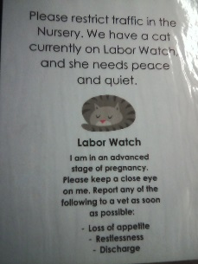 -or- 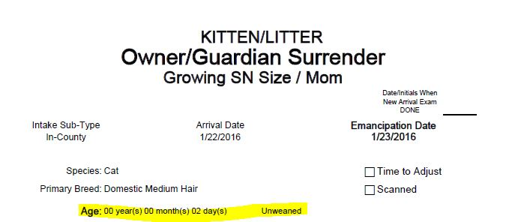

- Cats in Iso during breathing treatment (ok to see before or after). Will have a bedsheet draped over the cage.

- Cats marked as “Staff Only” or “No volunteer visit” with sign or hand-written. Examples:
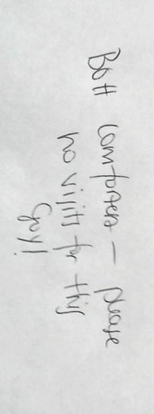


Okay to Visit
- If nothing from the “No Visit” list, okay to visit with Harbor Cats. You are “HSHV Official Business!”



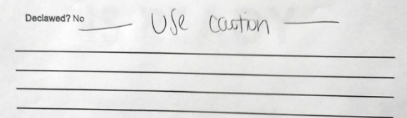
- Written notes that do not specificially say “No BOH Vol”

- “Waiting Barn Placement” 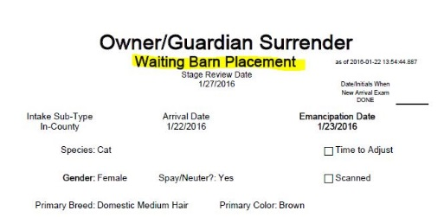

- “New Arrival” header/not fully checked in 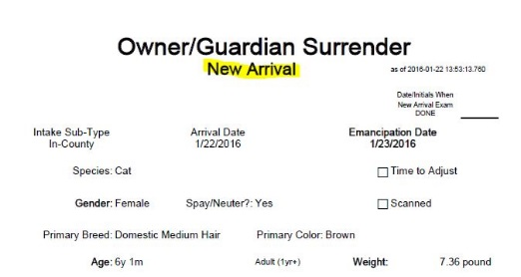 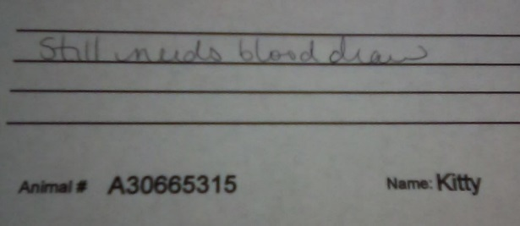

- If there is a carrier inside of cage
- Watch for “Wear Gloves [or other PPE]” signs, and follow diligently. Okay to visit, unless otherwise noted. Those should be your last visit of the day.

