Cat Comforting Areas - FOH Map

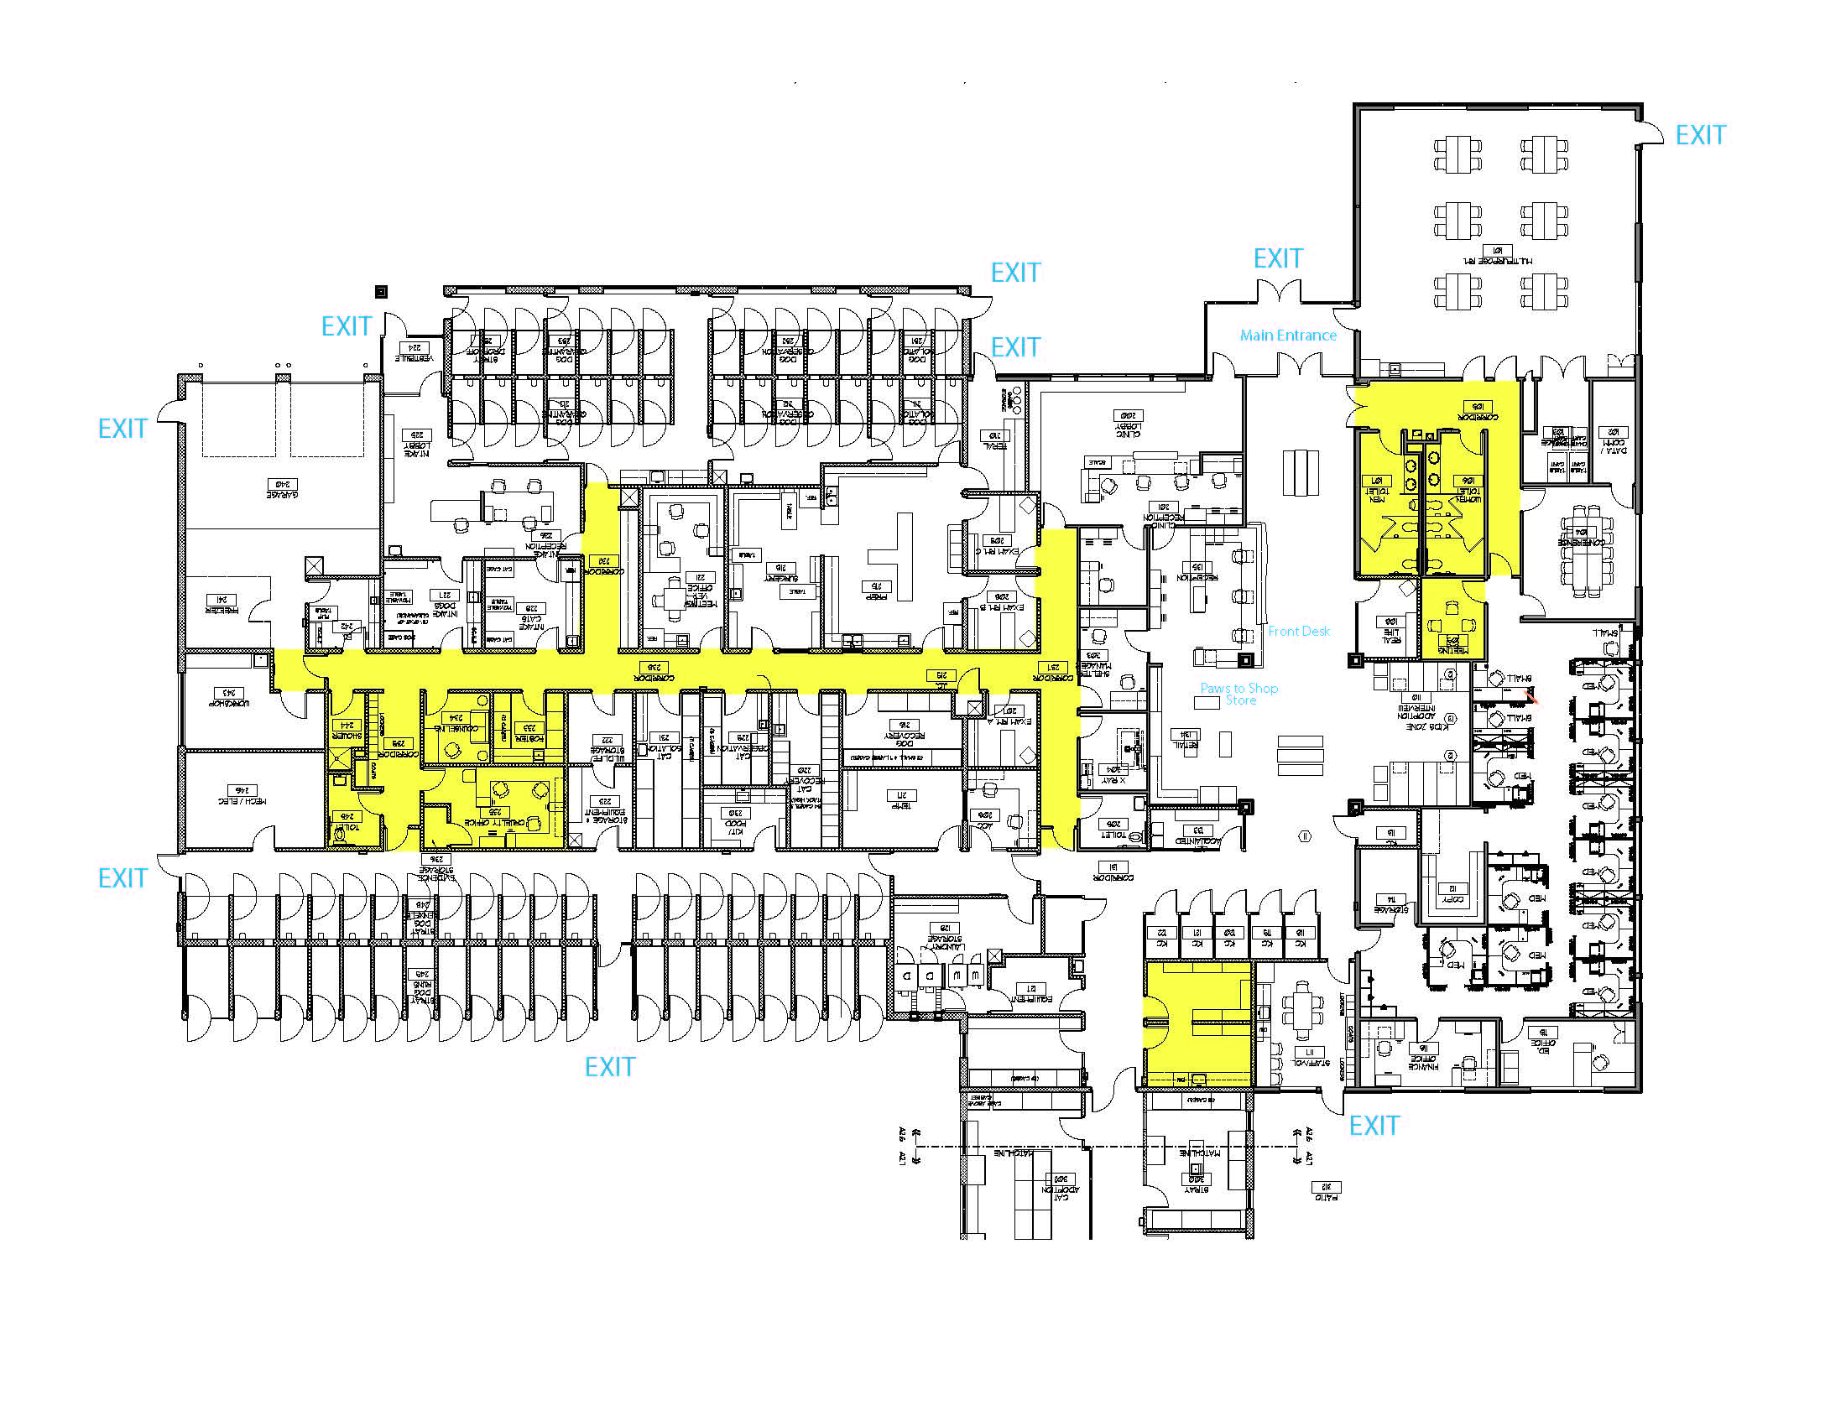
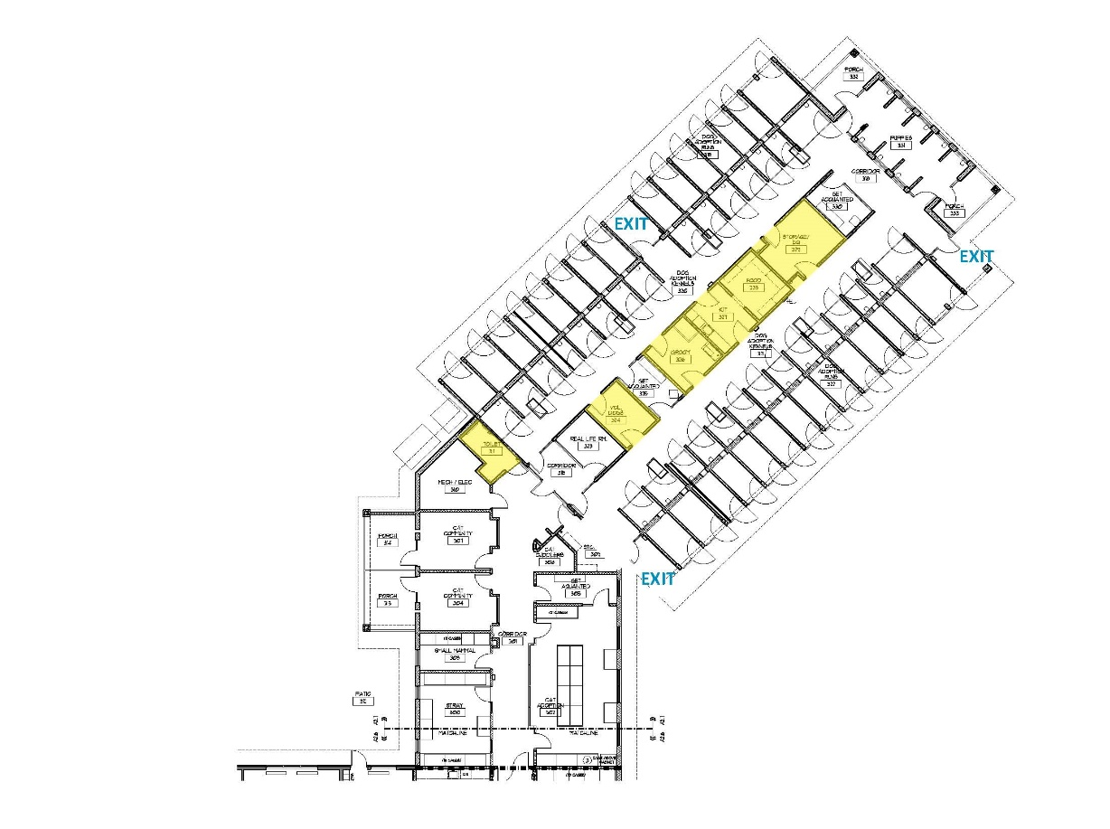
Behavior Office
Laundry Room
Main Entrance
Public Rest Rooms
Adopt Front Desk

Purrs
Plaza
Meow Meadows

Downtown Cats

Uptown Cats
Camp Kitten
Cat Kitchen
Condos
Condo
Condo
Condo Real Life Rm
Condo Real Life Rm

Education Center

