JV Small Mammal Training: Rabbit Habits

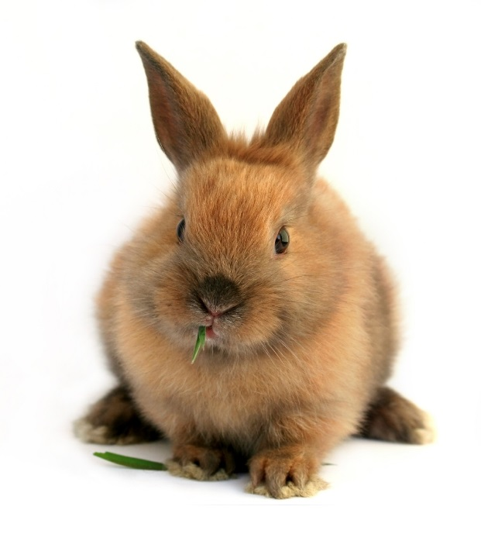
Basic Information
A well cared for domestic rabbit can live
8-12 years. Adult bunnies over a year old
are relatively easy to litter train and are
less destructive than younger bunnies,
especially if they are spayed or neutered.
Rabbits come in many different breeds
and sizes, and each rabbit is unique with
his/her own individual personality. In
general, large rabbits tend to be more
laid back and easy going than smaller
breeds.

Domestic rabbits are highly social,
affectionate, playful, and can make wonderful companions.

Chewing and Digging
Chewing and digging are normal, and pleasant behaviors for rabbits. Rabbit’s teeth and toenails grow continuously so rabbits need to chew and dig to keep them trimmed. Offering rabbits acceptable things to chew on keeps them from chewing things they shouldn’t. Some things rabbits might enjoy playing with or playing in are:
- Closed cardboard box with at least two doors for hopping in and out
- Large clay or cardboard tube to hide in
- Chew toys: apple tree branch, pine cones, anything made of untreated straw, wicker, or seagrass
- Toss toys: cardboard toilet paper roll, wire ball with a bell inside, large Lego blocks, etc.
- Empty margarine tubs and lids
- A towel to dig in or drape over a chair for the rabbit to run through
- Old telephone books and cardboard boxes for the rabbit to shred
- Box full of hay, straw, or shredded paper
- Little box full of sand or soil to dig and roll in

Feeding
An adult rabbit’s diet should be comprised of fresh, leafy green vegetables, unlimited timothy hay (not alfalfa), and pellets in moderation. Rabbits have a sensitive digestive system, and the timothy hay helps keep them healthy! Fresh water should be available at all times (see Rabbit Food handout for more information).
Exercise
Rabbits need a lot of exercise. At HSHV, we rotate each of the small mammals in the open room space so they can all get exercise each day. Rabbits also need traction to hop around in safety. Tile or laminate floors can be slippery for rabbits, and providing them with a carpet, or non-slide rug is helps them move around safely.
Friends
Rabbits are social creatures, and need the company of humans and/or animal friends. This is why your role as a small mammal comforter is so important in keeping our rabbits happy.
Rabbit Anatomy
The body structure of rabbits makes them very sensitive to being held. At HSHV, we ask our JV’s not to pick up rabbits. Instead, JV’s may sit next to them on the floor and pet them. This is what most rabbits prefer, and it is safer for them as well.

Information retrieved from ‘Bunny Basics: An Introduction to Rabbit Care’ by the Great Lakes Rabbit Sanctuary.

