JV Small Mammal Training: Rabbit Food

The following items may be
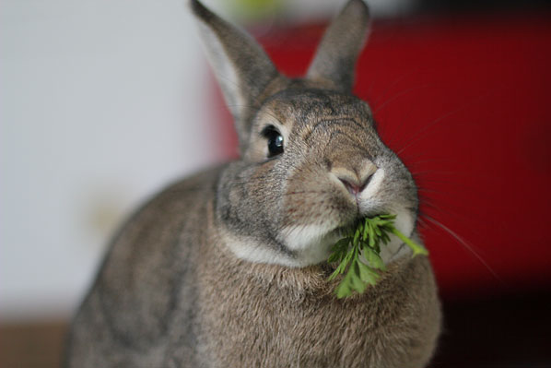
brought to feed to rabbits when
volunteering. While there are certainly other foods that rabbits can eat, at HSHV we ask that our JV’s only bring the items listed below. This will help our staff monitor the rabbits’ diets more accurately to make sure they are
getting all the nutrition they need and also not being over fed.

Rabbit Foods JV Can Bring*

Beets and beet tops
Broccoli (mostly leaves/stems)
Cilantro
Collard Greens
Dandelion Greens
Endive
Frisee
Green Leaf lettuce
Mustard Greens
Parsley
Chinese Pea Pods
Romaine Lettuce
Spring Mix (mesclun)
Watercress

*We prefer to feed our animals organic foods, but any store bought foods on the list above are acceptable. Vegetables found growing outside should not be fed to the rabbits because they may have been treated with pesticides.

