**Behavior Treatments for Shelter Cats**

**The “what’s” and “why’s” of treatment:**

* Think of treatment as intervention, modification or management
* Determined on behavior rounds by cat behavior specialist
* Determined during a comforter visit or staff interaction
* Based on notes on observation books
* You can decide who could benefit- staff AND volunteers
* Helps deal with shelter stress, can modify behaviors
* Daily comforting IS treatment
* Cage behavior vs true behavior- always remember that behavior witnessed in a cage is not true behavior. We’re treating the symptoms of shelter stress.
* Acute needs vs long term needs
  + Cats on medication or who require repeated, invasive handling have acute, immediate needs that don’t tend to linger post medical handling. The same is true of cats in the Wiggle Room due to lack of stimulation. Shy cats can fall in this category.
  + Cats who have a low threshold for handling, are frustrated, play rough or exhibit cat reactivity have long terms needs. Shy cats can fall in this category.

**What should I be looking for when comforting?**

* Blue Dot designation
* “Go Slow” signs
* “Keep Calm” signs
* Observed behavior
  + Each “type” of cat has a typical set of behaviors
  + Behaviors noted by other comforters or staff
  + Your own observed behaviors

**“Types” of cats who may receive behavior treatment:**

* Unsocial kittens
* The frustrated cat
* The scared cat
* The depressed cat
* The cat with a low threshold for handling
* The cat that just came in

**In all cases, basic needs should be met (i.e. blankets, hiding places)**

**Fearful Kittens:**

**Poorly socialized kittens, may be under socialized due to:**

* Feral, regardless of mom’s level of sociability
* Under socialized- just not enough human contact
* Handled improperly by caregiver(s)
* No real formula to determine how or why they’re under socialized, based on observed behavior

**Behaviors to expect from a fearful kitten:**

* Hissing/ spitting/ defensive behaviors
* Fleeing
* Immobile in cage
* Little response to handling
* Any combination of the above
* Must have a hiding place in the cage

**What to do:**

* Slow and steady- short, positive interactions are much better than long, fear inducing interactions
* Introduce yourself
* Offer food motivator, both staff and volunteers can do this
* Try toy therapy
* Pet only if they initiate it and keep it to safe spots (face/ cheeks/ chin/ forehead)
* Attempt pick up
* Stop if kitten struggles or retreats
* Encourage kitten back into your space
* Talk only/ Read to Calm is always ok!!
* Biggest hurdles for adoption: hissing when approached, being frantic when picked up. These are behaviors we’re working to modify.

**Behaviors to expect from a kitten who’s been handled improperly:**

* Chasing hands
* Afraid of hands
* Nipping/ biting
* Hard to redirect
* Often cat reactive
* Confident, bold
* Any combination of above

**What to do:**

* Redirect, redirect, redirect- offer toy (wand toy is often best) when behavior starts. Initiate play, direct away from hands and other body parts.
* Clicker training
* Reward good behavior (play, attention or food motivators)
* Offer appropriate behavior or remove yourself from visit- If rough play persists even with redirection and kitten continues to go after hands and other body parts, end session quietly.
* Hand shy kittens: desensitize to handling but watch for fear response
* Adoption hurdles for this group: biting and inappropriate play behaviors, these are the behaviors we’re working to modify.

**Frustrated Cats**

**Behaviors to expect from the frustrated cat:**

* Appear to be the most friendly, happy cats
* Reaching out from cage with paws
* Chasing hands in cage with paws/ teeth
* Vocal
* Escape behaviors: pacing, climbing bars, bolting from cage
* Cage destruction
* Bold, confident cat
* May sit at front of cage vocalizing
* Take in context… a cat displaying one of these behaviors may not be frustrated, we’re looking for a pattern of multiple behaviors.

**What to do:**

* Lots of cage enrichment!
* Items to redirect energy
* Good scratching outlets
* Clicker training
* Read to Calm
* Do not handle this cat:
  + Playtime only, appropriate play
  + Pet briefly when calm, safe spots only
  + Reward for appropriate play and calm behavior

**Active and Thinking Toys:**

* Anything tied to the cage bars or dangling from the cage bars to encourage batting and stretching.
* Small rolling balls or ping-pong balls to roll around the floor or hide under a towel. Plastic golf balls are even better as cats can get their claws in them.
* Mouse-sized toys for predatory play.
* Crazy Circle toy
* Any toy that they can hold between their paws and kick at, a sock filled with fluff material is good for this.
* Cardboard, newspaper or any other safe material that a cat can shred
* Wand type toys
* Food puzzle type toys
* Hiding treats in the cage for cat to seek out during the day

**Scared Cats**

**Behaviors to expect from the scared cat:**

* At back of cage, immobile
* Pupils dilated
* Eyes shut, feigning sleep
* Tense body, ears flattened
* Tail clenched to body
* May allow touch, no response
* Flee from interaction
* Can be defensive if flooded with too much stimuli
* Behavior hurdle: public can’t interact with cat. We’re working to reduce fear and stress, help them bond and engage with public.

**What to do:**

* Make sure these cats have a barrier. Kuranda beds need to be fully covered with a large towel and some fearful cats will also need a bed with high sides to hide in or behind under the Kuranda bed.
* Plenty of soft blankets or towels
* Large soft toys, such as teddy bears. These cats may not be interested in playing yet and toys may not be important to them yet.
* Soft, gentle, slow and quiet interactions. No loud noises or quick movements.
* Initial visits are done with food motivators. Do not try to touch the cat unless they show interest. Leave wet food, treats or something of higher value, but don’t force any interaction, especially in these beginning steps.
* Spend a few minutes talking to the cat and if he responds positively, offer your hand for him to smell.
* If cat shows interest in offered hand (may sniff hand or even rub their head on hand), gently scratch ears and cheeks, but no further.
* If, at any point, cat becomes tense or clenched during handling, slowly retreat from cage. Do not continue to handle cat if he stops showing social signals.
* If no interest in offered hand, just talk to cat quietly. Do not push interaction with cat.
* These are cats we can work with using food and treats. After speaking quietly to the cat, try offering some treats or tasty wet food on a tongue depressor to the cat. Even if they’re not interested in the food at first, this can be a way to begin to build trust and after a day or two, the cat may take food from you, enticing it closer to you in order to pet the cat slowly and gently. This takes time, and it’s important that the cat come to you and that you’re not imposing yourself on this cat in their space. It’s also helpful to simply drop some treats in the cage, talk softly and walk away. Short visits that result in something positive (food motivator) done multiple times a day can build trust.
* We can work with toys with some cats in this group, in the same way that we use food or treats. Try offering a toy, note body language. If the cat loosens with the toy nearby, offer a play session. Some cats respond more to play therapy than they do food treats or handling.
* Clicker training, see the Shy Cat Protocol
* Read to Calm

**Depressed Cats**

**Behaviors to expect from the depressed cat:**

* In our care, this is most commonly a previously social or accepting cat
* Most commonly a cat in iso or obs undergoing medical care
* May sit in cage without moving
* May often be sleeping, can be hard to wake and when they do wake, are disinterested in interaction
* No longer responsive to interaction
* May stop eating or grooming
* Chronic illness
* Scared/ fearful cats also go through this trajectory of behavior… this is fairly normal… we worry when a previously social cat exhibits these behaviors

**What to do:**

* Extra attention- needs to feel bonded and cared for
* Read to Calm could be appropriate here
* Very low impact handling
* May respond to play therapy
* Food motivators
* Talk only
* Lots of comfort items

**Cats with a Low Threshold for Handling**

**Behaviors to expect from cats with low threshold for handling:**

* May appear to be very social
* Often a confident cat, but fearful cats can find themselves here, too
* Draws you in with paws- leads to inappropriate attention seeking
* Tail swishing during visit
* Ears twitch
* Pupils dilate
* Increases attention seeking, more actively seeks attention
* Turns head to hand
* Stares at hand
* Body may stiffen during interaction
* May flop on side for attention during visits (belly pets = never!)
* Often, body is loose just prior to bite attempt, it’s important to look at tail, ears, pupils and other body responses during visits.

**What to do:**

* Read to Calm could be appropriate here
* Short visits only for these cats. The quality of the visit is more important than the length of time spent with them.
* Let the cat come to you, don’t reach into their space or “force” attention on them.
* Let the cat rub on your hands, petting only the face and cheeks. No full body pets at any point during the visit.
* Offer a treat or wet food if the cat remains calm for attention, very gradually increasing the length of the visit using treats as the reward for allowing handling.
* Stop petting if at any point the cat shows behaviors listed above. Leave cage on a positive note, speaking calmly and gently to the cat but not offering more attention other than this.
* If cat is displaying above behaviors when you enter the cage, don’t touch them. Speak quietly to them for a moment and leave cage, return if cat seems to have calmed at a later point.

**New (to HSHV) Cats**

**The cat that just came in:**

* Talk only/ Read to Calm is always ok
* Less is always more
* No full body pets, ever
* Focus on safe spots
* Play therapy
* Food motivators
* We don’t know this cat, tread lightly
* Allow cat to interact on their terms

**Odds and ends:**

Cat in the litterbox….

* + It’s ok!!
  + May need a different bed
  + Can simulate litterbox with a box with a towel in it under the kuranda
  + May just need time
  + They may prefer this substrate…. And that’s ok as long as this isn’t a fear response.

Cats who lick hands…

* + Don’t let them!
  + Redirect with a toy or treat
  + Everyone finds their way!
  + Reward behaviors that we want
  + Redirect/ remove interaction for behaviors we don’t want
  + Be consistent
  + Be patient
  + Be alert to body language
  + Ongoing process

Sanity Keeper:

* Follow instructions on intervention log
* May encompass treatments from frustrated, shy or depressed cat
* Use your best judgement, let the cat lead the visit
* Read to Calm could be appropriate

**Play Therapy:**

* Start with a variety of toys. The goal is to find something that the cat responds to, initiating their natural prey drive.
* We’re looking for a toy or multiple toys that the cat will pounce on, run after or interact with in a game of chase, or “cat and mouse”.
* Allow cat to win the game multiple times during the session, making the game rewarding for him.
* Slow the pace of the game down until the toy “dies”, allowing the cat to calm down and relax naturally.
* Offer a treat of some kind when game is over and cat is calm.

**Simple Enrichment Ideas:**

* Variety of toys in cage and hanging from cage doors. Rotate toys regularly.
* Provide a variety of scratching surfaces: cardboard, carpet, sisal
* Boxes or paper bags with treats hidden in them
* Soothing music in cat areas
* Perpetual motion devices, disco balls or mobiles near or in cat areas, making sure that the cats can see them easily
* Bird feeders near windows that cats can see out of
* Treat balls, feeding puzzles, toys that dispense treats or dry kibble offered daily, on rotation to entire population. Stuff mini-kongs with tuna or wet food.
* Out of cage time as much as possible, offering opportunities to play, hunt and engage in more natural activities
* Clicker training
* Feliway
* Daily, scheduled and directed time with people.

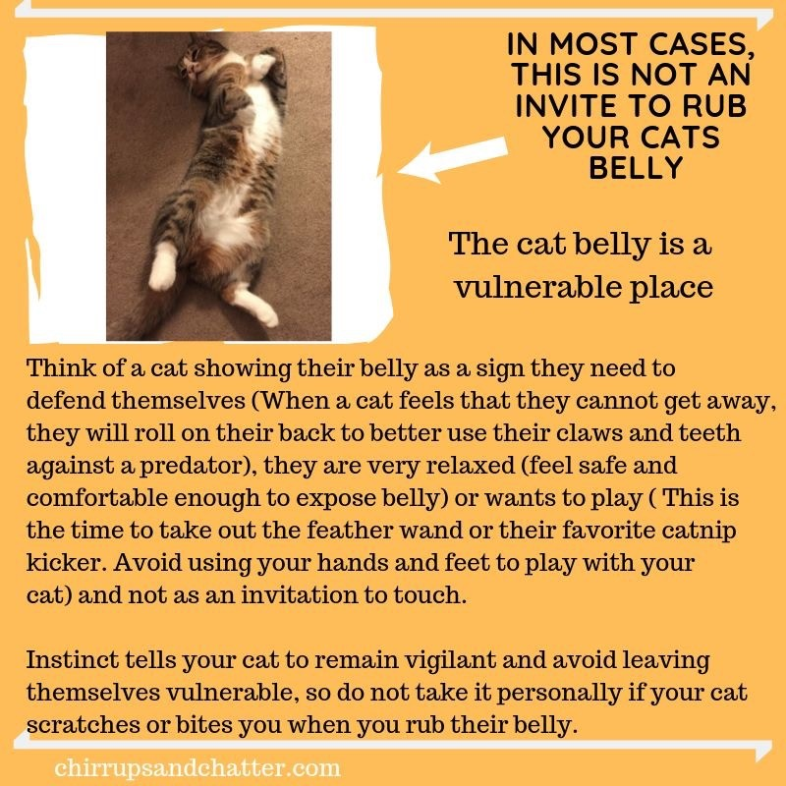

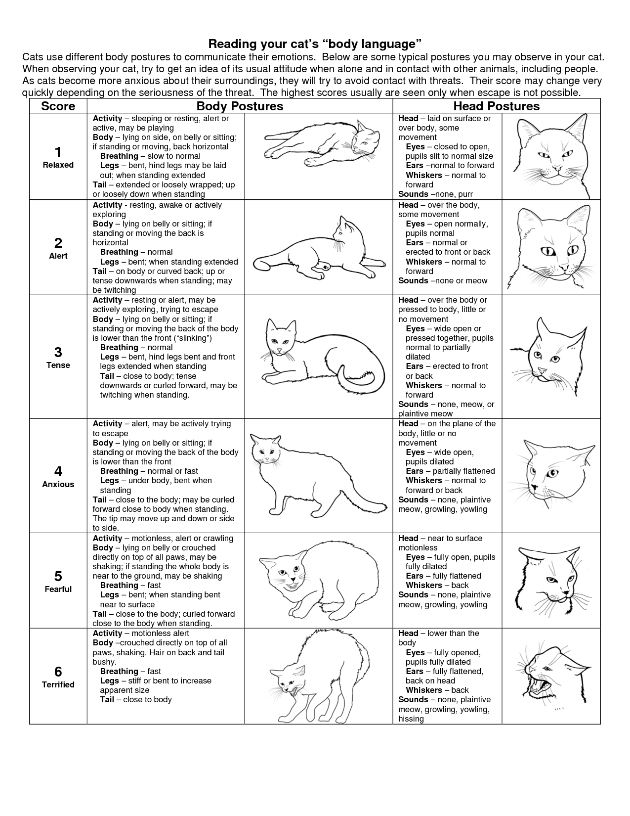

**What Is My Cat Thinking: Part 1 – Facial Expressions**

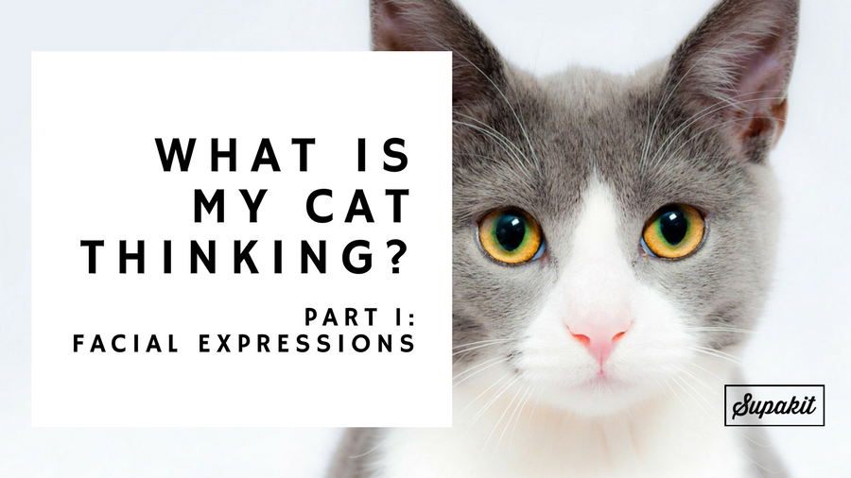

As a cat owner, I spend a lot of my time wondering what’s going on behind my cats’ inscrutable facial expressions. Life would be much easier if I could master the art of cat mindreading! But while actual mindreading is a bit beyond our reach, our cats *do*try and tell us what they’re thinking and feeling on a daily basis… through their wonderfully expressive body language and the many sounds that they make.

The only question is, is it possible to translate this language into one we can understand? When I first started looking into this subject I secretly thought I was reasonably in tune with my cats’ body language, or at least had the basics down. But when I started looking into it I was amazed at how many signs and signals our cats are giving out…and how many I had been misinterpreting or missing altogether!

I ended up with such a diverse list of expressions that I’m going to divide the subject up over three posts:

1. Facial expressions (this post)

2. [Body language](http://blog.supakit.co/cat-thinking-part-2-body-language/)

3. [Vocalisations](http://blog.supakit.co/cat-thinking-part-3-vocalisations/)

Each feature of your cat’s facial expressions, body language and vocalisation gives you a glimpse of their inner thoughts and feelings. But reading their body language becomes most powerful when you learn to interpret it as a whole. That’s what our goal will be over this three part series, piecing together all of the features so that you can learn to tell, at-a-glance, what might be going on in your cat’s innermost thoughts.

This is Part 1, so in this post we’ll be exploring the marvellous facial expressions our cats use to communicate.

Top of Form

**EAR POSITION**

Bottom of Form

[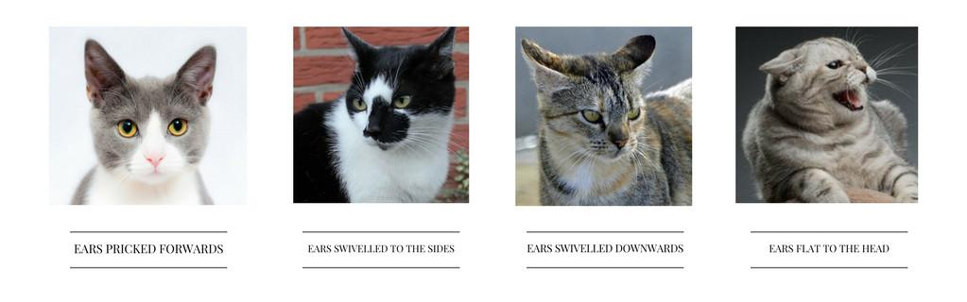](http://blog.supakit.co/wp-content/uploads/2018/02/Copy_of_SPRINGTIME-9.jpg)Cat body language and facial expressions – ear positions

Cats’ ears never cease to amaze me. Never mind the fact that they are super sensitive, able to eavesdrop on secret mouse chatter (as we saw in a previous [post](http://blog.supakit.co/put-bell-cats-collar/)), can move independently of each other and swivel almost 180 degrees… they are also a head-mounted semaphore system to show other cats how they are feeling! And us, if we can just learn to decipher their signals…

**EARS PRICKED FORWARDS:**

A cat with its ears pricked forwards is feeling **confident,** **playful**and **focused.**

**EARS SWIVELLED TO THE SIDES:**

When your cat swivels its ears to the sides, that means it is feeling **aggressive**, and is threatening to attack.

**EARS SWIVELLED DOWNWARDS:**

Your cat is trying to be **deferential** and diffuse a fight – usually with another cat. It’s saying ‘I don’t want to have to fight you, but I will if I have to’, and trying to decide between standing its ground and fleeing in fear.

**EARS FLAT TO THE HEAD:**

This is an **extreme defensive** pose, one that a cat will only display this if all other conflict-diffusion attempts have failed. The ears are folded for protection should a fight ensue. This is a pose that says ‘I said I DIDN’T want to fight but you’ve pushed things too far. I’m ready to defend myself’.

Reference: ([Ferguson, A. F. 2012](https://books.google.co.uk/books?id=CyrA16_yt3MC&pg=PA12&dq=cat+vibrissae+forwards&hl=en&sa=X&redir_esc=y#v=onepage&q=forward&f=false))

**WHISKER POSITION**[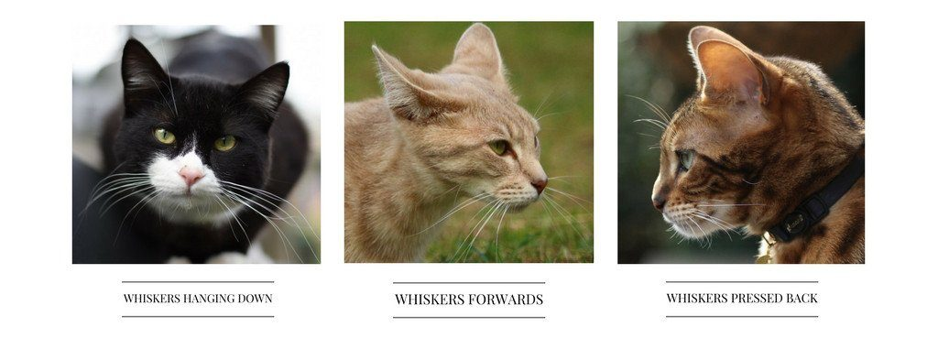](http://blog.supakit.co/wp-content/uploads/2018/02/Copy_of_Copy_of_SPRINGTIME.jpg)

Your cat’s whiskers are highly sensitive touch receptors, which they use to sense the world around them. But they are also windows into their soul.

If you look at the whiskers on their cheeks you’ll notice that they’re arranged in four horizontal rows. Amazingly, your cat can move the top two rows independently of the bottom two. And the position of their whiskers can tell you a lot about how they are feeling.

**WHISKERS HANGING DOWN:**

When your cat is feeling **happy**and **relaxed** it will let its whiskers hang to the side, in a neutral position. ([Shaw, J & Martin, D. 2014](https://books.google.co.uk/books?id=AaXpCgAAQBAJ&amp;pg=PA57&amp;dq=cat+expression+whisker+forward&amp;hl=en&amp;sa=X&amp;ved=0ahUKEwiejfzog6TTAhWrK8AKHbJxAes4ChDoAQg7MAU#v=onepage&amp;q=cat%20expression%20whisker%20forward&amp;f=false))

**WHISKERS POINTED FORWARDS:**

When a cat’s whiskers are pointing forwards it means they are interested and aroused – they want to absorb all of the information they can from the environment ahead of them. This happens when a cat is **hunting**, **threatened**, **aggressive** or **seriously interested** in something up ahead. ([Overall, K. 2013](https://books.google.co.uk/books?id=HHoK9PKpqn4C&amp;pg=PA328&amp;lpg=PA328&amp;dq=leyhausen+cat+expression&amp;source=bl&amp;ots=7t9kyWrNSt&amp;sig=OGsZM7uBfsjvwr4Ihy5fNQfGazU&amp;hl=en&amp;sa=X&amp;ved=0ahUKEwio79Kk_6PTAhWJAcAKHX6YCeMQ6AEIWzAO#v=onepage&amp;q=whisker&amp;f=false))

**“Forward-directed whiskers in a fight indicate that the cat, when it contacts the foe, intends to bite seriously.”  
(**[**Fraser, A. F. 2012**](https://books.google.co.uk/books?id=CyrA16_yt3MC&amp;pg=PA12&amp;dq=cat+vibrissae+forwards&amp;hl=en&amp;sa=X&amp;redir_esc=y#v=onepage&amp;q=forward&amp;f=false)**, emphasis mine)**

**WHISKERS PRESSED BACK AGAINST THE CHEEKS:**

Whiskers pressed backwards indicate that your cat is feeling **scared**. They are streamlined for flight – your cat is planning its escape! ([Fraser, A. F. 2012](https://books.google.co.uk/books?id=CyrA16_yt3MC&amp;pg=PA12&amp;dq=cat+vibrissae+forwards&amp;hl=en&amp;sa=X&amp;redir_esc=y#v=onepage&amp;q=forward&amp;f=false))

**NOSE TOUCH**

[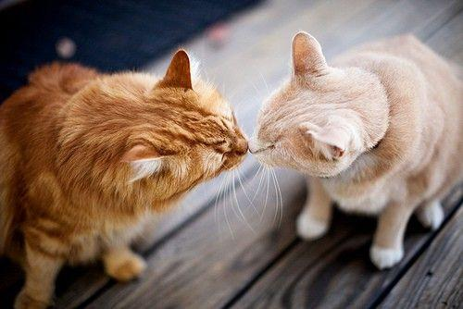](http://blog.supakit.co/wp-content/uploads/2018/02/August-10-2012-01-43-05-wtw.jpg)

This is an affectionate cat greeting. When cats meet other cats that they are already friends with they will often touch noses to say hi ([Rochlitz, I. 2007](https://books.google.co.uk/books?id=0HmB3ix5IQ8C&pg=PA7&dq=domestic+cat+nose+touch&hl=en&sa=X&redir_esc=y#v=onepage&q=domestic%20cat%20nose%20touch&f=false)).

**STARE**

[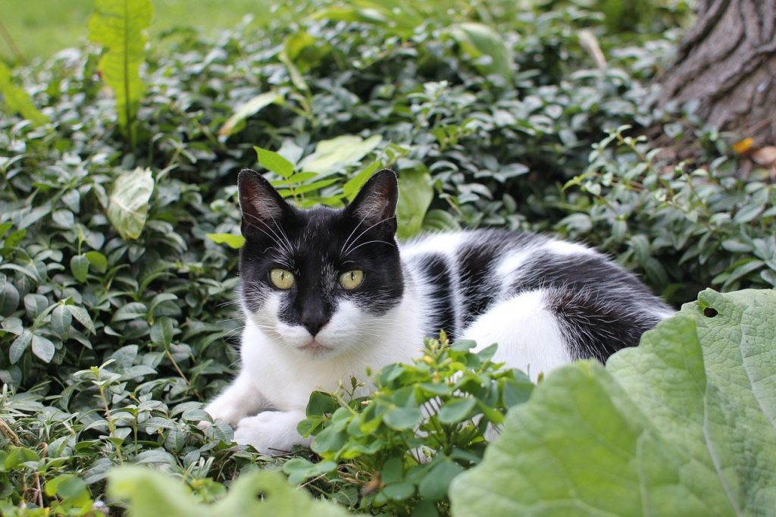](http://blog.supakit.co/wp-content/uploads/2018/02/cat-763387_1280.jpg)

For cats, a direct stare is a challenge or threat. It is usually displayed by self-assured, forceful cats, particularly those who are trying to dominate or engage another cat in a fight.

These rules extend to their interactions with humans too – if you stare your cat in the eyes it will think you are confronting it, and become very uncomfortable ([Overall, K. 2013](https://books.google.co.uk/books?id=HHoK9PKpqn4C&pg=PA331&dq=domestic+cat+blinking&hl=en&sa=X&redir_esc=y#v=onepage&q=stare&f=false)). Fortunately, that doesn’t mean you must never look at your beloved moggy again – you just need to keep another cat trick up your sleeve

**BLINKING**

[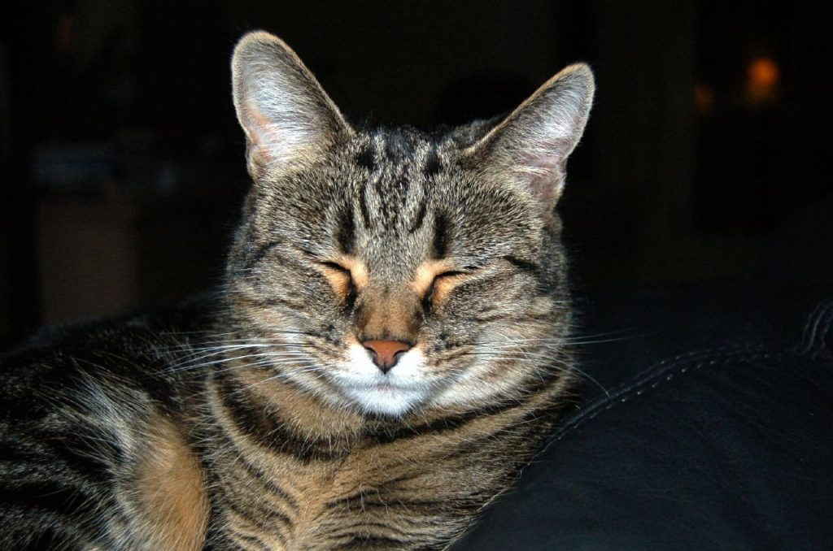](http://blog.supakit.co/wp-content/uploads/2018/02/254607833_9c62f9f58e_o.jpg)

Photo credit: [Flickr @ilovebutter](https://www.flickr.com/photos/jdickert/254607833)

The opposite of the aggressive stare is the slow blink. Because staring is so intimidating, non-aggressive cats will often slowly blink at other cats or humans when looking at them intently, to show that they don’t mean it in a hostile way.

If you want to look at your cat but don’t want it to feel threatened, you can use the slow blink too.

Some popular websites and books claim that this is a cat’s version of ‘kissing’ – a way of showing love, but there isn’t much evidence to support that. That’s not to say that cats don’t express affection, they just seem to do so in other ways. We’ve already seen one – the nose touch – and we’ll come across several more before this series is out! ([Turner, D. C. & Bateson, P. 2013](https://books.google.co.uk/books?hl=en&lr=&id=4avCAQAAQBAJ&oi=fnd&pg=PA185&dq=cat+slow+blinking+affiliative&ots=RaynWzOUv4&sig=NS8wNwwDmR3_zU0OQvYtgm35-Jg#v=onepage&q=blink&f=false))

It’s also worth noting that blinking and half-blinking have also recently been found to be associated with fear, so it’s important to read your cat’s overall body language before drawing any conclusions. If they are showing other serious signs of fear, then their blinking is probably not an affectionate gesture – it could be an expression of anxiety instead. ([Bennett, V. et al 2017](http://www.sciencedirect.com/science/article/pii/S0376635716303321))

**THE FLEMHEN RESPONSE / GAPE**

[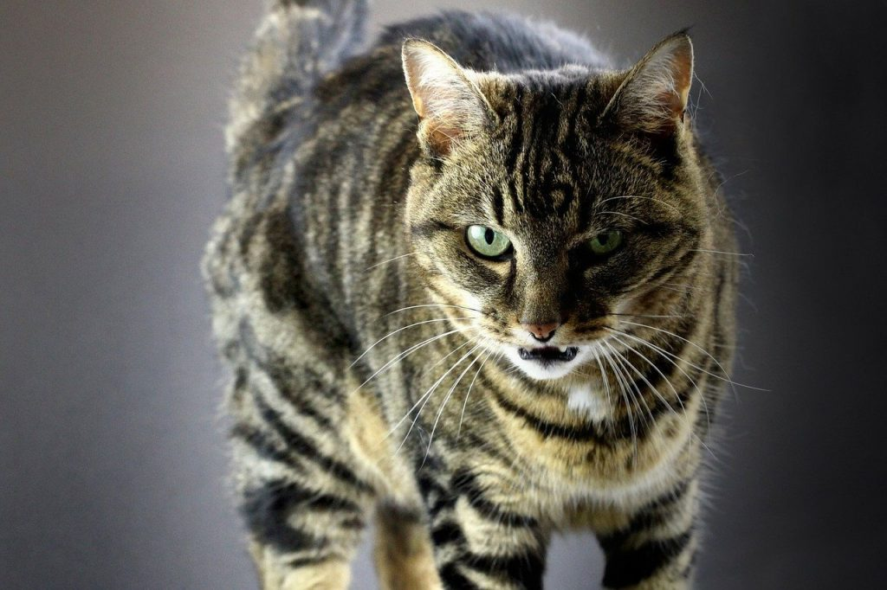](http://blog.supakit.co/wp-content/uploads/2018/02/tabby-219763_1280.jpg)

Have you ever noticed your cat suddenly stop still in its tracks and leave its mouth hanging open for an eerie few seconds? In our house it has rather crudely been termed ‘bum face’ because we first noticed Lyra doing it after she had been licking her… ahem, rear end… and it looked like she was doing everything she could to avoid putting her tongue back in her mouth!

The reality is much more interesting…

It turns out that apart from their tongue and nose, cats have a whole extra organ for sensing smells and tastes that we just don’t have. It’s called the vomeronasal organ and the entrance to it is located in roof of their mouth. So, when cats smell something they want to get some extra detail on, they hold their mouth open to let the odour reach their vomeronasal organ.

**“When cats use [their vomeronasal organ], they first locate the source which is to be investigated, approach it closely, and then hold their heads still with partially retracted lips. This grimace, known by the German word *flehmen*, may be held for a second or more and is often misinterpreted as a threat. After sampling in this fashion, the cat usually licks its nose.”  
(**[**Turner, D. C. & Bateson, P. 2013**](https://books.google.co.uk/books?hl=en&lr=&id=4avCAQAAQBAJ&oi=fnd&pg=PA185&dq=cat+slow+blinking+affiliative&ots=RaynWzOUv4&sig=NS8wNwwDmR3_zU0OQvYtgm35-Jg#v=onepage&q=blink&f=false)**)**

If you see your cat gaping, or flehmening, as it is known – that means that it has picked up a scent that it finds totally fascinating. Often it is gland secretions or bodily fluid (e.g. urine) from other cats, but cats also flehmen in response to many other non-cat odours.

**LICKING**

**[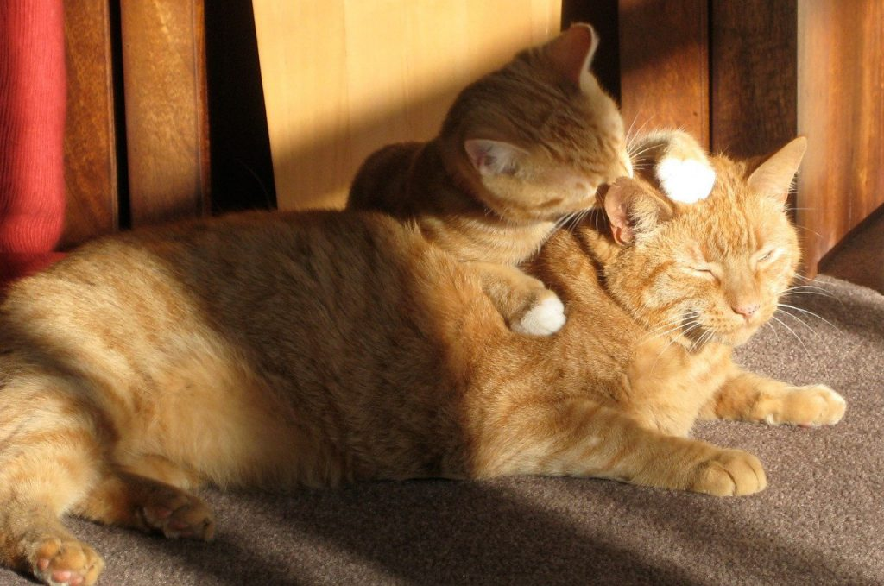](http://blog.supakit.co/wp-content/uploads/2018/02/two-ginger-cats-650546_1280.jpg)**

Cats that are friendly with each other tend to engage in a behaviour called allogrooming – mutual licking of the fur around the head and neck. It’s considered the ‘glue’ of a harmonious cat colony. This licking can also be done by cats to their human owners – some enjoy it, others might prefer not to be slobbered all over – but as far as your cat’s concerned this is their way of showing how much they like you, and how bonded they feel to you.

It seems that the human way of repaying the favour is with stroking. It’s no coincidence that the parts of a cat’s body that they are most happy for us to stroke are the exact same places that they would let another cat allogroom them! ([Crowell-Davis, S. et al 2004](https://www.researchgate.net/profile/Sharon_Crowell-Davis/publication/8582646_Social_organization_in_the_cat_A_modern_understanding/links/0c960538cd9a60e2d7000000.pdf))

**THE PUPILS [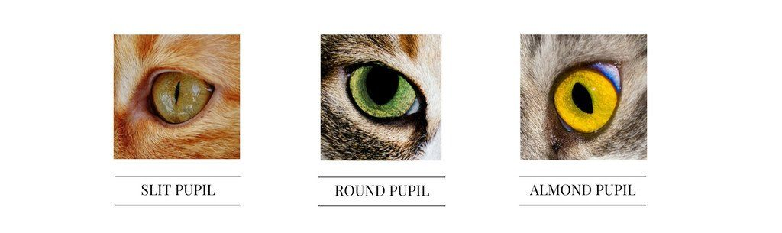](http://blog.supakit.co/wp-content/uploads/2018/02/Copy_of_Copy_of_SPRINGTIME-2.jpg)**A cat’s pupils are widely considered to be one of the most useful giveaways as to how they are feeling. They change rapidly as a situation develops, giving you instant insights into their mood and mental state. They also give a sense of the intensity of your cat’s mood – across all pupil types, the larger the pupil, the stronger your cat’s particular emotion. You just have to remember to factor in the ambient light conditions, because cats will also open their pupils up when light is low to get more light into their eyes! ([Little, S. 2011](https://books.google.co.uk/books?id=rnyakraHGdcC&pg=PT97&lpg=PT97&dq=the+most+instructive+feline+signal+is+the+pupil&source=bl&ots=cgm5RWrokj&sig=ZMWDvrZ8Q4YRUe6TtVZXoGiU_20&hl=en&sa=X&ved=0ahUKEwjYrb-G3KTTAhVkLcAKHXcABdgQ6AEIJjAA#v=onepage&q=the%20most%20instructive%20feline%20signal%20is%20the%20pupil&f=false))

SLIT PUPILS:

This is a cat’s normal, **relaxed** state. ([Overall, K. 2013](https://books.google.co.uk/books?id=HHoK9PKpqn4C&amp;pg=PA328&amp;lpg=PA328&amp;dq=leyhausen+cat+expression&amp;source=bl&amp;ots=7t9kyWrNSt&amp;sig=OGsZM7uBfsjvwr4Ihy5fNQfGazU&amp;hl=en&amp;sa=X&amp;ved=0ahUKEwio79Kk_6PTAhWJAcAKHX6YCeMQ6AEIWzAO#v=onepage&amp;q=whisker&amp;f=false))

ROUND PUPILS:

A cat that is **scared**will have completely round pupils, even in bright light. The larger their pupils are, the more scared they are feeling. Large round pupils are also common when a cat is **hunting**, when their gaze is locked onto a particular target. ([Overall, K. 2013](https://books.google.co.uk/books?id=HHoK9PKpqn4C&amp;pg=PA328&amp;lpg=PA328&amp;dq=leyhausen+cat+expression&amp;source=bl&amp;ots=7t9kyWrNSt&amp;sig=OGsZM7uBfsjvwr4Ihy5fNQfGazU&amp;hl=en&amp;sa=X&amp;ved=0ahUKEwio79Kk_6PTAhWJAcAKHX6YCeMQ6AEIWzAO#v=onepage&amp;q=whisker&amp;f=false))

BIG ALMOND SHAPED PUPILS:

A cat that is feeling **tense** or **aggressive**will have almond shaped pupils. The larger their almond-shaped pupils are, the more aggressive they are feeling.

And that brings us to the end of Part 1! If you’re anything like me you’ll now be going back through all of your old photos of your cats, looking at their whiskers and pupils and starting to hazard a guess at they were *really*feeling at the time! I’d love to hear your thoughts in the comments below – have you started seeing your cat in a new light? Does your cat have any unique facial expressions that we haven’t covered here? What do *you* think your cat is thinking?

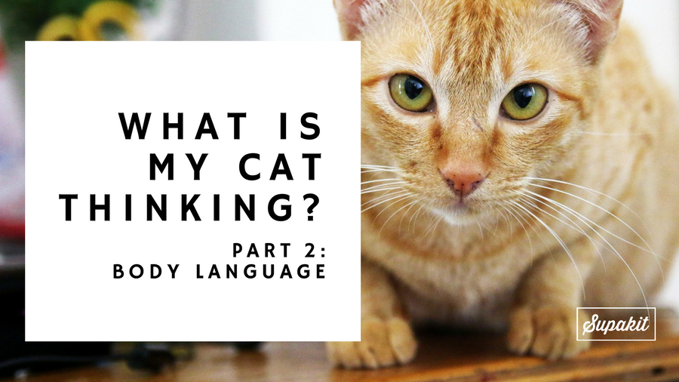**What Is My Cat Thinking: Part 2 – Body Language**

In this week’s post we’re going to be taking on the fascinating subject of cat body language. We’ll learn how to decipher the secret signals that reveal your cat’s innermost thoughts and feelings.

This is part two of a three part series, so if you missed last week’s post ([Part 1: Facial Expressions](http://blog.supakit.co/cat-thinking-part-1-facial-expressions/)) it’s well worth having a read. Each part of the series hones in on one set of cat signals.

[1) Facial expressions](http://blog.supakit.co/cat-thinking-part-1-facial-expressions/)

**Part 2: Cat body language (this post)**

[Part 3: Vocalisations](http://blog.supakit.co/cat-thinking-part-3-vocalisations/)

Taken alone, they each give you an amazing insight into your cat’s feelings, but the real superpowers come from reading them all at the same time. By the end of this series we’ll learn to do just that to become kitty mindreaders!

**TAIL POSITION**

I could write a whole blog post just on cats’ tails! Who knew that they were broadcasting so much information through those big furry antennae. Here’s what you need to know to become an expert tail-reader.

TAIL UP

When you cat bounds towards you with its tail up and a little curled over at the top, you should feel honoured, because it’s saying a big cheery ‘**hello**‘ to you!

[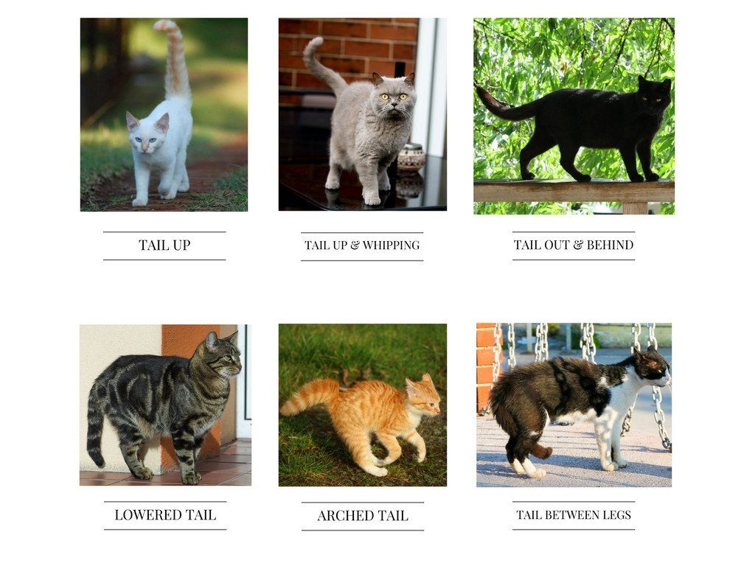](http://blog.supakit.co/wp-content/uploads/2017/04/Copy_of_Tail_Position.jpg)Cats do this to other cats that they enjoy the company of, as a greeting, and to signal that they ‘come in peace’. Amazingly, there is even evidence to show that the curl of the tail is often directed towards the person or cat they’re greeting, so if you’re in a room with other people you can work out if it’s actually *you*that your cat is happy to see!

TAIL UP AND WHIPPING

This is a classic show of **frustration** – maybe you’re taking too long to get your cat’s food from packet to food bowl, or maybe you’ve gone to the bathroom and shut kitty on the other side of a closed door!

TAIL OUT & BEHIND

This is the tail of a **happy, relaxed and confident** cat, who is **alert** and willing to explore the environment around them.

LOWERED TAIL

A lowered tail usually denotes **aggression**, but to interpret this one properly it’s important to take a closer look at your cat’s tail. Is the tail rigid and flicking? In that case, it’s probably a sign of ***offensive* aggression** – for instance if your cat is trying to scare off another cat that has wandered into its territory.

If however the tail is more floppy, then it’s more likely your cat is showing ***defensive* aggression** – for instance if it has just been threatened by a more dominant cat. This is a tail that says “watch out, I will defend myself if you start something”.

ARCHED TAIL

An arched tail that is raised in the middle is another sign of **defensive aggression** – often seen in a cat that is feeling threatened and trying to dissuade its aggressor from launching a physical attack.

TAIL BETWEEN LEGS

A cat whose tail is curled between its legs is trying to withdraw from social interaction – this is a tail that says “**Please leave me alone**“. It can be used as a submissive signal in a threatening interaction with another cat, the equivalent of “I’m not causing any trouble here so can we PLEASE not fight?!”

Reference: [Overall, K. 2013](https://books.google.co.uk/books?id=HHoK9PKpqn4C&pg=PA331&dq=domestic+cat+blinking&hl=en&sa=X&redir_esc=y#v=onepage&q=stare&f=false)

[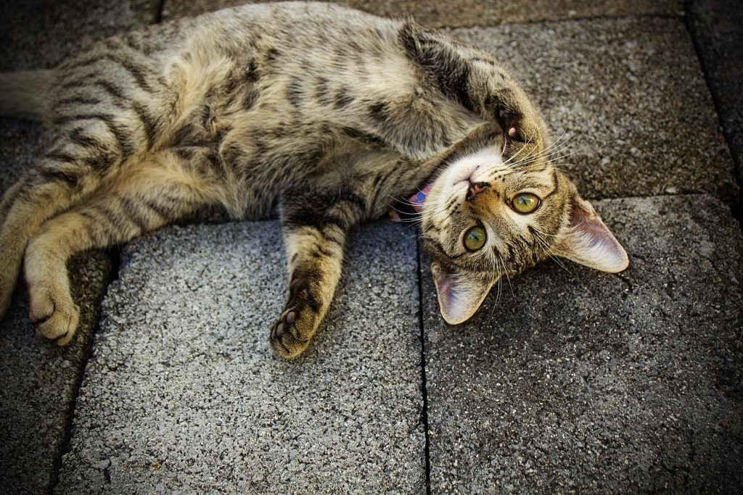](http://blog.supakit.co/wp-content/uploads/2017/04/cat-676079_1920.jpg)**BELLY UP**

When a cat shows its underbelly it is generally a sign of **vulnerability** – it is revealing its soft furry bits to the world!

What that means depends on the context. If it’s in the middle of a fight with another cat, it is trying to show that it is completely**defenceless** **and doesn’t want the fight to go on**. In these cases a cat will also usually bring their back feet up with their claws out, as an insurance policy in case their opponent doesn’t back down. But crucially, if their opponent *does* back down, a cat that has shown its belly *won’t*chase after them to try and catch them unawares. In this way the belly up pose is like saying “truce, truce” – a cat promise to not carry the fight on.

If however your cat has just rolled over and proudly displayed its belly to you, that is a sign that it trusts you and is **relaxed in your presence**. For many cats, it is *not*a sign that they want a belly rub… after all, they just said “here are my most precious fluffy bits” so reaching in and trying to grab them can freak them out. However, there *are* cats that like a good belly rub. The best advice is to follow their lead… if they get upset or try and scratch you when you pet them around the belly area, then that’s a sure sign they wanted their belly to go un-rubbed! ([Overall, K. 2013](https://books.google.co.uk/books?id=HHoK9PKpqn4C&pg=PA331&dq=domestic+cat+blinking&hl=en&sa=X&redir_esc=y#v=onepage&q=stare&f=false))

**HEAD BUTTING**

[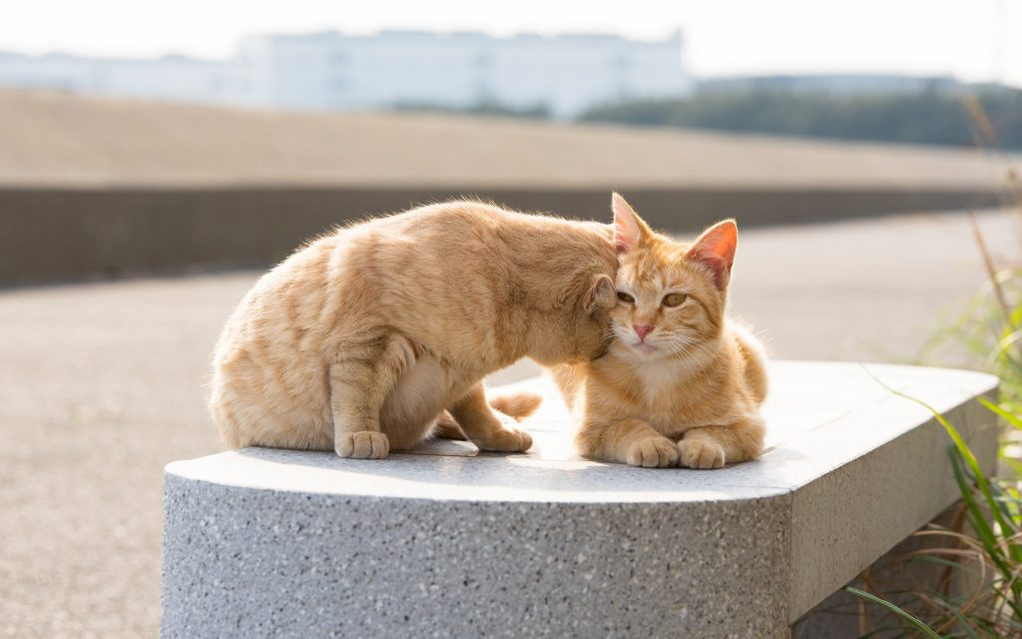](http://blog.supakit.co/wp-content/uploads/2017/04/26284866950_9963c9a31d_k.jpg)

Photo credit: [Flickr @torne](https://www.flickr.com/photos/_torne/26284866950)

When our cats head butt us, and each other, they are actually engaging in a behaviour that scientists call ‘bunting’. This is usually a very **friendly** signal. Between cats it’s really only observed between cats that consider themselves part of the same colony or ‘gang’.

The purpose seems to be exchanging scent from the scent glands on the head and neck. Many experts believe that these mingled scents create a sort of ‘colony odour’. This scent would help them work out who is and isn’t in their gang. It’s a nice theory, but conclusive evidence for this ‘colony odour’ has yet to be found ([Crowell-Davis, S. et al 2004](https://www.researchgate.net/profile/Sharon_Crowell-Davis/publication/8582646_Social_organization_in_the_cat_A_modern_understanding/links/0c960538cd9a60e2d7000000.pdf)).

What we do know is that if your cat is head butting you, it is affectionately rubbing its scent on you and saying ‘we’re in the same gang’.

Sometimes cats end up rubbing other things but as a proxy for us. If you’ve ever noticed your cat rubbing a chair or table leg when you come home, that’s what’s going on. In these cases the cat isn’t marking the furniture – it’s using it as a stand-in for you!

Your cat’s bunting behaviour can also tell you something about their confidence level. Research suggests that confident cats bunt more than less confident cats, and those lower down in the pecking order. ([Overall, K. 2013](https://books.google.co.uk/books?id=HHoK9PKpqn4C&pg=PA331&dq=domestic+cat+blinking&hl=en&sa=X&redir_esc=y#v=onepage&q=stare&f=false))

**ARCHED BACK**

**[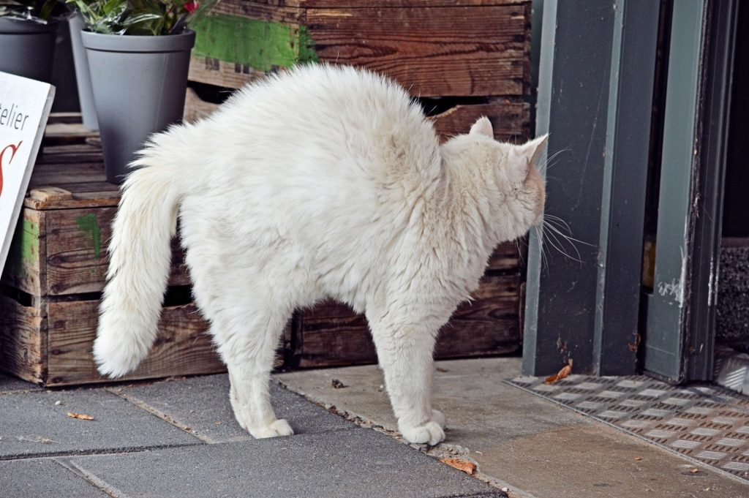](http://blog.supakit.co/wp-content/uploads/2017/04/hoge-rug.jpg)**This has been called the ‘Halloween Pose’ – a cat with an arched back like this is on **high alert**. They will usually be in a confrontation with another cat. This posture signals that they are ready to fight, defensively or aggressively, depending on what the other cat does next.

They usually perform this posture side-on for maximum effect, and it’s intended to show how fearsome they are. But if you want to know whether it’s just a bluff, it’s worth watching what a cat’s ears are doing… if they start to fold them back and down flat to their head it suggests that they might not be very confident of winning, and are getting ready to tuck them out of the way of harm during the impending fight ([Bradshaw, J. 2013](https://books.google.co.uk/books?id=iU8PAAAAQBAJ&dq=john+bradshaw+cat+sense&hl=en&sa=X&ved=0ahUKEwjHsLOy4bjTAhWQJFAKHWg0AScQ6AEIIzAA)).

**LOW CROUCH**

[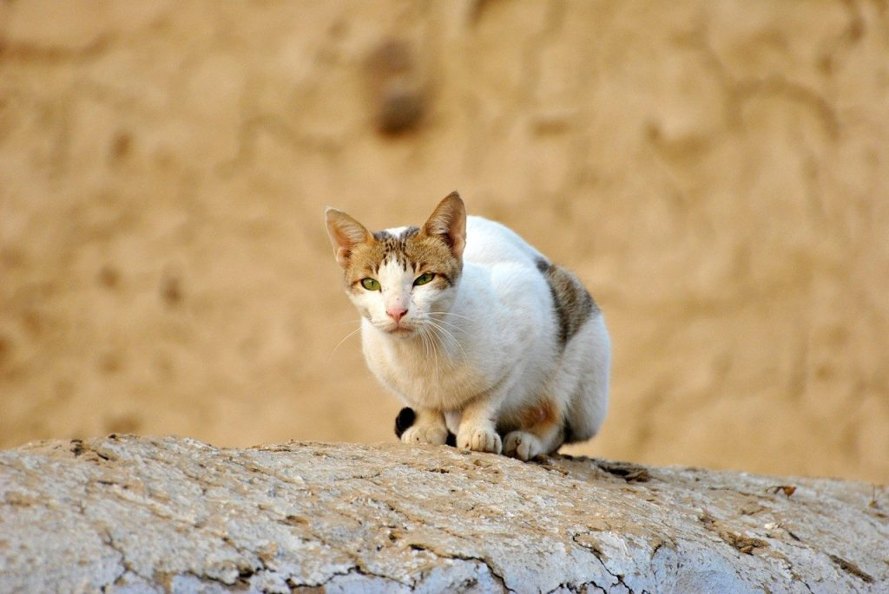](http://blog.supakit.co/wp-content/uploads/2017/04/cat-72568_1280.jpg)

A cat that is in a low crouch is being **defensive**. It will usually wrap its tail around its body to signal to other cats that it doesn’t want to interact, and also to keep its tail safe if it ends up in a confrontation ([Overall, K. 2013](https://books.google.co.uk/books?id=HHoK9PKpqn4C&pg=PA331&dq=domestic+cat+blinking&hl=en&sa=X&redir_esc=y#v=onepage&q=stare&f=false)).

**LOAF**

[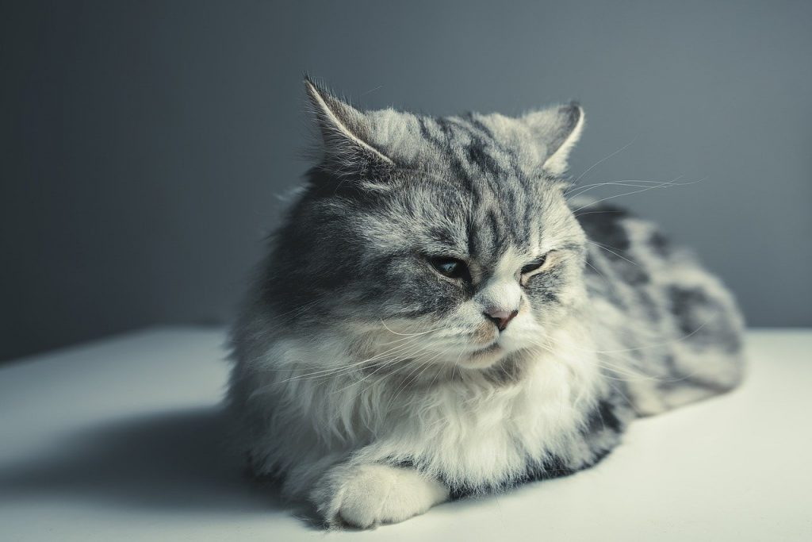](http://blog.supakit.co/wp-content/uploads/2017/04/cat-1897224_1280.jpg)

The difference between a ‘loaf’ and a ‘low crouch’ is in your cat’s front paws. In a crouch their elbows will be angled up so that they’re ready to move at a moment’s notice. In the loaf they’ll rest flat on the ground and the paws may be tucked under the body.

This is generally a **contented** pose, but it also signals that your cat doesn’t really want to interact. This is cat for “**please do not disturb**!” ([Eilert-Overbeck, B. 2009](https://books.google.co.uk/books?id=tzMc_j6Ho6UC&pg=PA47&dq=cat+loaf&hl=en&sa=X&ved=0ahUKEwiJhP_G6LjTAhUKL1AKHUA1Ceg4FBDoAQgiMAA#v=onepage&q=cat%20loaf&f=false))

**LOUNGING**

[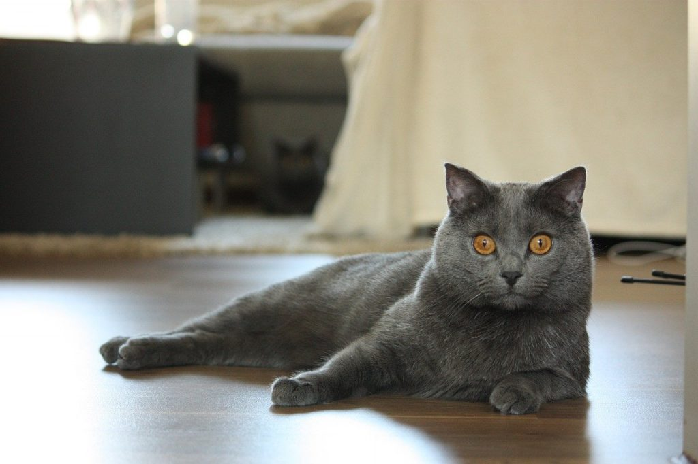](http://blog.supakit.co/wp-content/uploads/2017/04/chartreux-2095639_1280.jpg)

This is the sign of a **fully relaxed** cat, who is feeling content and open to interaction.

**ELEVATED RUMP**

[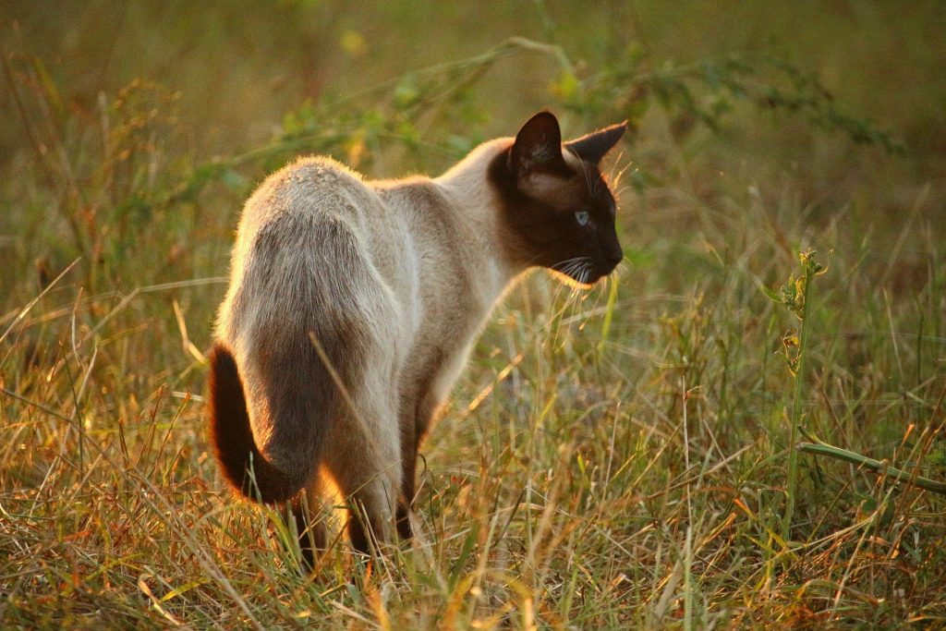](http://blog.supakit.co/wp-content/uploads/2017/04/cat-1623868_1920.jpg)

And last but not least we have the elevated rump! This is a sign of **aggression and swagger**. A cat that feels it has the upper hand in an altercation will usually adopt an elevated rump first and keep it throughout the interaction.

Some cats have so much confidence in their abilities that they maintain an elevated rump at all times. This is a super assertive cat who wants to let all potential challengers know that it’s not worth *bothering*trying to knock them off their pedestal! ([Overall, K. 2013](https://books.google.co.uk/books?id=HHoK9PKpqn4C&pg=PA331&dq=domestic+cat+blinking&hl=en&sa=X&redir_esc=y#v=onepage&q=stare&f=false))

That concludes our run down of the key cat body language cues to look out for if you want to ‘read’ what is going on in your cat’s mysterious inner thoughts!

I’d love to hear your thoughts and anecdotes – are there any unusual poses your cat makes that we haven’t covered here, and you’d love to know the meaning of?! Share your stories in the comments below or over on [Instagram](https://www.instagram.com/supakitstore/).

**What Is My Cat Thinking: Part 3 – Cat Vocalisations**

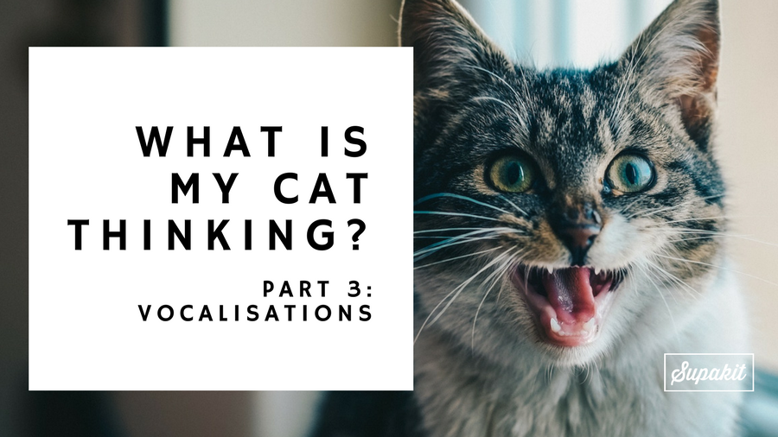

We’ve made it to part 3 of our *What is my cat thinking?*series, and this week it’s all about cat vocalisations. The final piece in our cat-mindreading jigsaw.

If you haven’t read the other parts in this series it’s well worth checking them out.

[1) Facial expressions](http://blog.supakit.co/cat-thinking-part-1-facial-expressions/)

[2) Body language](http://blog.supakit.co/cat-thinking-part-2-body-language/)

3) Cat Vocalisations (this post)

You don’t have to read them in order, but each one contains essential clues that you’ll need to work out what’s going on in your cat’s mind. By combining the knowledge in all three, you can gain a really deep insight into your cat’s thoughts and feelings.

Without further ado, let’s get on with finding out what all those kitty noises REALLY mean…

**THE PURR**

Individual cats vary in how vocal they are, but ALL cats purr. They start doing it almost from birth as kittens, and it’s thought that they use their purrs to request milk from their mothers.

In grown up cats, we tend to think of purring as an expression of pleasure, but it is actually a much more complex signal than that. For instance, cats have been found to produce a special type of purr that has some ‘meow’ sounds mixed in. They use this special purr to try and get food (it’s different enough that we humans can tell the difference between the two). Cats have also been known to purr when in severe pain.

Overall, the picture that emerges is that purring is not so much ‘pleasure’ as a care-soliciting signal – your cat’s way of saying ‘love me / pet me / feed me / take care of me / soothe me’, depending on the situation it finds itself in ([Turner, D. C. & Bateson, P. 2013](https://books.google.co.uk/books?id=m-NRAgAAQBAJ&pg=PA48&dq=cat+vocalisations+mouth+open&hl=en&sa=X&ved=0ahUKEwi3yrPctcnTAhWJIlAKHaL6D3AQ6AEIJjAA#v=onepage&q=cat%20vocalisations%20mouth%20open&f=false)).

**MEOW**

After purring, meows are the second most common noise that our cats like to make.

Interestingly, adult cats rarely if ever meow to each other. Instead, a cat’s meow is entirely for our benefit.

**“Cats needs to meow because we humans are generally so unobservant…we do, however, reliably look up when we hear something unusual, and cats quickly learn that a meow will grab our attention”  
(**[**Bradshaw J. 2013**](https://books.google.co.uk/books?id=iU8PAAAAQBAJ&dq=bradshaw+cat+sense&hl=en&sa=X&ved=0ahUKEwjhn5SKu8nTAhVlJMAKHcXDAhgQ6AEIIjAA)**)**

It’s thought that meow is an elongated and modified version of ‘mew’ – a kitten’s distress call that they use to get the attention of their mothers. ([Tabor, R. 2003](https://books.google.co.uk/books?id=7-PDwgJHVS8C&pg=PA87&dq=cat+growl+behavior&hl=en&sa=X&ved=0ahUKEwjv1bXkysnTAhVDI8AKHcq2BmQQ6AEIIzAA#v=onepage&q=cat%20growl%20behavior&f=false))

Once cats realise that they can use a meow to get our attention, they then work on fine-tuning their meows to try and tell us what they are after. Over months and years of trial and error, every cat settles into a language and pattern of meows that is unique to them and their owner.

**“A secret code of meows and other vocalisations develops between each cat and its owner, unique to that cat alone and meaning little to outsiders”  
(**[**Bradshaw J. 2013**](https://books.google.co.uk/books?id=iU8PAAAAQBAJ&dq=bradshaw+cat+sense&hl=en&sa=X&ved=0ahUKEwjhn5SKu8nTAhVlJMAKHcXDAhgQ6AEIIjAA)**)**

Typically, cats will have subtly different meows for ‘I’m hungry’, ‘You’re annoying me’, ‘Love me’, ‘There’s something in my way’ and ‘I’m scared’ – that you and you alone will be able to decipher ([Overall, K. 2013](https://books.google.co.uk/books?id=HHoK9PKpqn4C&pg=PA350&dq=cat+vocalisations&hl=en&sa=X&redir_esc=y#v=onepage&q=meow&f=false)).

**CHATTER**

I remember the first time I saw Lyra chattering at a bird – I thought she had been possessed! I always assumed that this was her way of ‘talking’ to the birds. Like: ‘Hey bird, you may be laughing now, but I’m going to catch you….one day!’

Instead it turns out that chatter is a sound of excited frustration… and that cats also make this sound in other scenarios where they might get frustrated, for instance if they almost catch a fly and it escapes from their grasp ([Overall, K. 2013](https://books.google.co.uk/books?id=HHoK9PKpqn4C&pg=PA350&dq=cat+vocalisations&hl=en&sa=X&redir_esc=y#v=onepage&q=meow&f=false)).

**TRILL**

Mother cats trill to their kittens to tell them come near. When your cat trills in greeting to you, scientists believe that it is trying to convey the same meaning – ‘come close to me’! ([Tabor, R. 2003](https://books.google.co.uk/books?id=7-PDwgJHVS8C&pg=PA87&dq=cat+growl+behavior&hl=en&sa=X&ved=0ahUKEwjv1bXkysnTAhVDI8AKHcq2BmQQ6AEIIzAA#v=onepage&q=cat%20growl%20behavior&f=false))

**GROWL / SNARL / HISS / SHRIEK**

**“Sounds made with the mouth held open in a relatively constant position are usually related to aggression. These include the growl, yowl, snarl, hiss, spit and shriek.”  
(**[**Crowell-Davies, S. et al 2004**](http://katzen-verstehen.at/wp-content/uploads/2013/04/social-organization-of-the-cat.pdf)**)**

This set of sounds, which are all associated with a similar open-mouthed position, are all warning sounds – designed to warn the other party about the consequences if they continue with their actions ([Overall, K. 2013](https://books.google.co.uk/books?id=HHoK9PKpqn4C&pg=PA350&dq=cat+vocalisations&hl=en&sa=X&redir_esc=y#v=onepage&q=meow&f=false)).

They can be offensive or defensive, and it’s thought that the pitch and volume of these sounds may convey honest information about the cat’s size and strength – in order to scare their opponent into backing down ([Turner, D. C. & Bateson, P. 2013](https://books.google.co.uk/books?id=m-NRAgAAQBAJ&pg=PA48&dq=cat+vocalisations+mouth+open&hl=en&sa=X&ved=0ahUKEwi3yrPctcnTAhWJIlAKHaL6D3AQ6AEIJjAA#v=onepage&q=cat%20vocalisations%20mouth%20open&f=false)).

At the mild end of the spectrum is the low growl. After the growl comes the hiss – which some have suggested is designed to mimic the sound of a snake. It is, after all, a sound that a cat’s wild predators would have been very attuned to ([Morris, D. 2009](https://books.google.co.uk/books?id=Q3ysT6xTJu4C&pg=PA45&dq=cat+hissing&hl=en&sa=X&redir_esc=y#v=onepage&q=cat%20hissing&f=false)). If the other cat or person doesn’t get the message after a hiss, they will usually escalate to a loud shriek. It’s the ultimate in cat language for “leave me alone!”

That concludes our guide to cat vocalisations. Have we missed any? Does your cat make a sound that’s not on this list? Let me know – on Instagram ([@supakitstore](https://supakitco.myshopify.com/admin/blogs/81428107/articles/www.instagram.com/supakitstore)) or in the comments below, and I will do my very best to find out what it means!