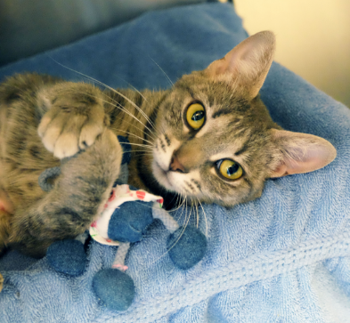
Giving back to the community is just good business!

Holding a fundraiser for HSHV helps both the animals AND your business. By aligning yourself with one of Washtenaw County’s favorite charities, you demonstrate the shared values of thousands of animal lovers in our community. Charitable giving is also an excellent morale booster and team builder for staff!

Here are some ideas:
- Penny Wars: Does your office have more cat people, or dog people? There's one way to find out! Get your staff involved and set out a jar for each team: Cats, Dogs, Horses, Birds, Bunnies, etc! Then the battle begins - pennies increase each team's score, silver or paper money decrease it. Whether you're adding to your favorite team or putting mischievous silver or paper in another team's jar, it all supports the animals!

- Denim Day: Staff can donate to wear jeans to work! This could also work for an ugly sweater day during the holidays ;)

- Parking Spot Auction: Exactly what it sounds like…auction off the prime parking spots at your workplace to raise money for the animals!

- Day of Giving: Do you work for a restaurant, brewery or retail store? Consider donating a percentage of the day’s proceeds to HSHV – we can help promote your day of giving, and even bring a dog to visit and greet customers! This is also a great idea for bottle releases and new product releases.

- Pie-eating Contest: Have everyone participating make a donation for entry! Have a fries-eating contest, cake eating contest, you name it!

- Silent Auction or Raffle: Always a fun addition to a staff appreciation party or a public event!

- Cutest Pet Contest: Who has the cutest pet? Invite staff to hang up their beloved pets pictures, then vote for your favorites using change!

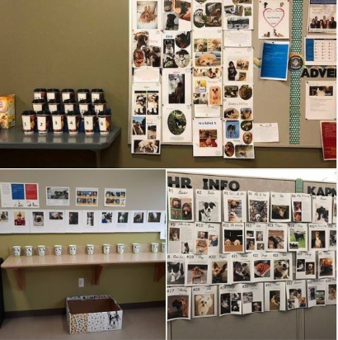

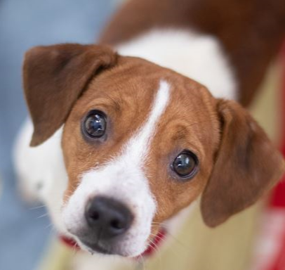
- Holidays: Take advantage of the giving mindset around the holidays to encourage charitable donations. This could be a “Giving Tree” around Christmas, a “Treat Fund” around Halloween or selling carnations or Hershey’s “puppy” kisses around Valentine’s Day.

