**Cat Comforting Areas - FOH Map**

Key Sign Out location for Condo and Communal Rooms (behind front desk).

Additional Kitten Housing

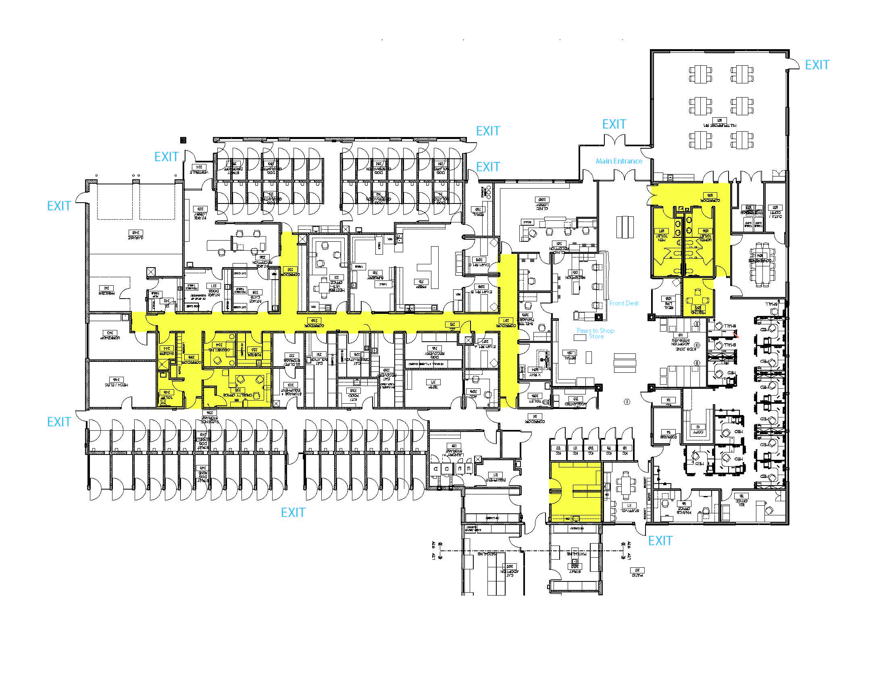

**Behavior Office**

**Laundry Room**

**Main Entrance**

**Public Rest Rooms**

**Adopt Front Desk**

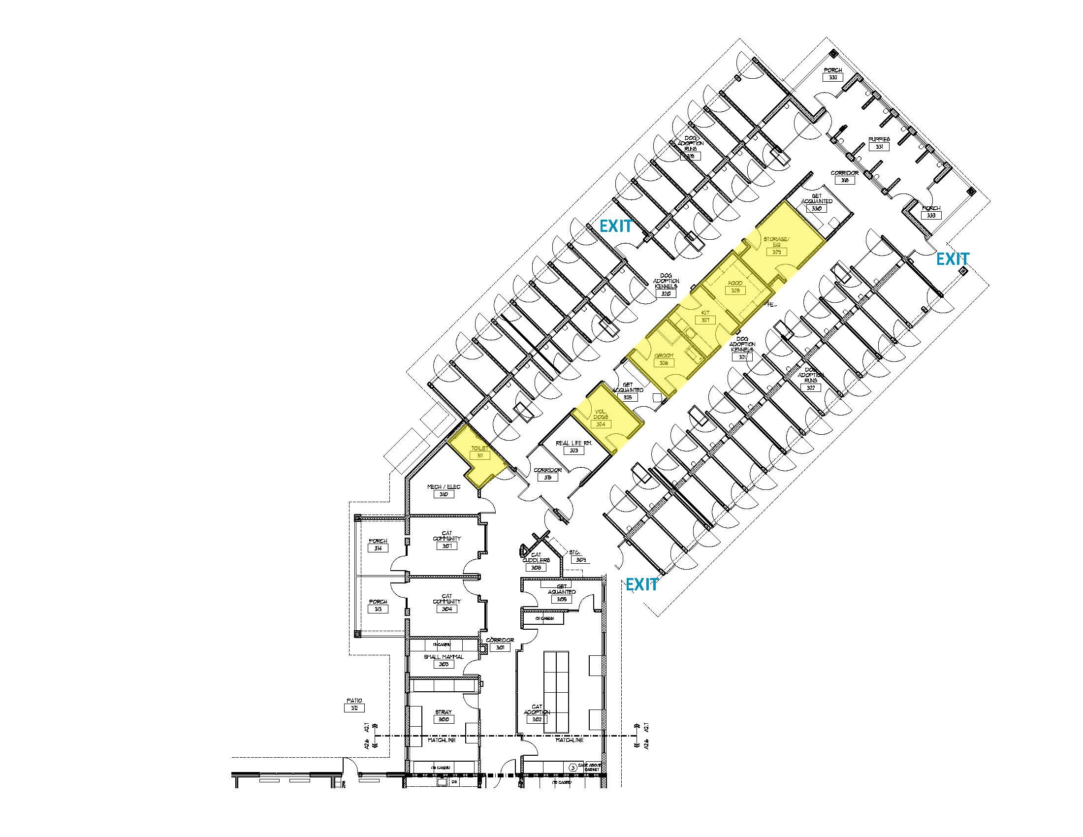

**Purrs**

**Plaza**

**Meow Meadows**

**Downtown Cats**

**Uptown Cats**

**Camp Kitten**

**Cat Kitchen**

**Condos**

**Condo**

**Condo**

**Condo Real Life Rm**

**Education Center**