The Humane Society of Huron Valley
Camp Programs Handbook
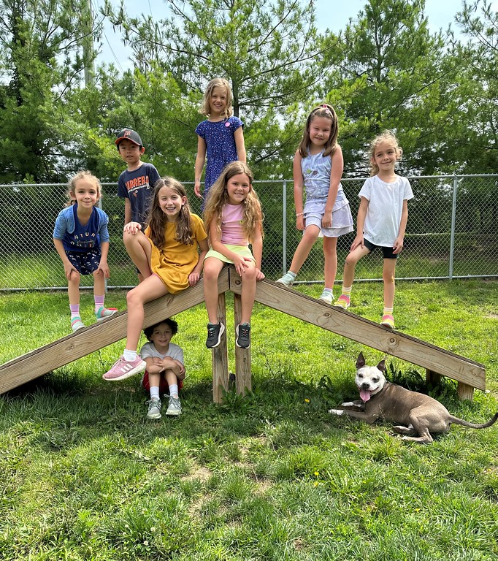

Camp Contact Information
Phone: 734-661-3583
E-mail: humaneed@hshv.org
Address: 3100 Cherry Hill Rd
Ann Arbor, MI 48105

Welcome
HSHV is happy to offer summer programming for a variety of ages. While each program is designed to be fun and engaging for its designated age group, all summer programs contain similar elements such as, making crafts (including enrichment for our shelter animals), playing games, participating in interactive educational activities, and, of course, meeting animals!

Program | Age Group
Camp Paws Jr. | Children entering Young 5s or Kindergarten
Camp Paws | Summer: Children entering 1st-6th grade  School Year: Children in K-5th
Animal Care Residency | Youth entering 7th-10th grade

What to Know Before Camp Registration

Registration
Registration for Camp Paws is done completely online. We are not able to process registrations in-person or over the phone. To allow campers to attend more than one week of Camp PAWS each summer, we offer a “session 1” and “session 2.” Each week of session one will contain the same activities and the same applies for the weeks of session two. If your camper would like to attend more than one week of Camp PAWS, we ask that they attend one week of each session.

If you make any errors or forget to include any information during registration, you can contact our team at humaneed@hshv.org with any corrections.

Waitlist
Families can add their name for any week(s) that they desire. If a space becomes available, all families on the waitlist for that week will be notified and the space will be filled on a first come, first serve basis via email. Due to time constraints, we will no longer be contacting families individually when openings arise.

Scholarships
A limited number of scholarships for Camp PAWS summer programs are available for families who are in financial need and would not otherwise be able to attend. Applications should be filled out and submitted online. Scholarship applicants should not register for camp as spaces for scholarships are separate from general registration. Preference is given to first time applicants. Participants may be awarded up to one scholarship per camp season and up to two scholarships in a lifetime. To apply for scholarship, visit our website.

Cancellation Policy
Summer Camp Paws: If a cancellation is made prior to May 1st, a refund will be given less a $50 non refundable deposit, per participant. For cancellations after May 1st, no refunds will be given.

School Year Camp Paws: If a cancellation is made prior to 60 days before the start of a camp, a refund will be given less a $50 non refundable deposit, per participant. For cancellations less than 60 days, no refunds will be given.

We’re sorry, we are not able to waive our policy for any reason nor are we able to have a child’s sibling or friend attend in your child’s place. Unfortunately, transfers to a different week or to a different child are not able to be done on our end and require being issued a refund (the above policy applies) and re-registering for another available week, if space is available. Please email humaneed@hshv.org to request a cancelation if needed.

Age Groups
We want all camp participants to have activities and lessons that are fun and engaging for them. For this reason, we designate our weeks of camp for specific age ranges.

For summer Camp Paws, we base registration on the grade the child will be entering in the fall. Because our programming is designed for the specific age group, we ask that all participants register for their designated weeks. At this time, we do not make exceptions to the grade level designations but do offer an all ages week to allow for sibling groups to attend together.

For school year camps, all ages are grouped into one camp. These camps are open to children currently enrolled in K-5th.

Allergy Statement
Food Allergies: Our shelter regularly uses peanut butter, cheese, and shellfish to feed and medicate animals. We are not a peanut free camp environment. During camp, peanut butter smells will be in the air and some dogs may have peanut butter near their mouths. We cannot guarantee that children will not come into contact with allergens such as peanut butter, cheese, shellfish.

Animal Allergies: Children will come into contact with animals, which may include, but are not limited to: cats, dogs, ferrets, rabbits and reptiles. We cannot guarantee that children will not come into contact with any of these animals.

Special Needs
We ask parents/guardians to share information regarding special education needs their child may have. Camp staff may contact you to discuss any accommodations your child may need to have a safe and happy experience! We, unfortunately, are not able to provide one-on-one support to Camp Paws participants. If your child would benefit from a support person/aide to be successful at Camp Paws, please let us know during registration! Support person must be provided the family and be 21 or older.

What to Know for Camp
Staff
All staff and volunteers involved in our programming have a full background check and go through training on safety and health procedures. All camp staff members are CPR/First Aid certified. Our Lead Humane Educator is a certified teacher with over 30 years of classroom experience.

Communication
Communication between camp staff and parents will primarily happen via e-mail. This year we will also be using the Class Dojo platform to post camp information (such as schedule, forms, etc.) and pictures from the day’s activities. Parents/guardians are under no obligation to download or use the Class Dojo app.

During the camp day, the best way to reach staff is by calling 734-661-3583.

What to Wear
Please send your child to camp in attire appropriate for play and animal interaction. We don’t recommend wearing anything that you or your camper will mind potentially getting dirty!

Campers are required to wear closed-toe shoes for their safety. Campers wearing flip-flops or other open-toed shoes will not be allowed to participate in animal interactions.

Lunch, Snacks and Water Bottles
Camp Paws will provide a small snack to campers every afternoon. Snacks provided by Camp Paws are always vegetarian. A list of the week’s snacks can be found on Bloomz or by asking camp staff. Campers are welcome to bring their own snacks if the ones provided aren’t to their liking.

Families will be responsible for providing a lunch and drink for their child for each day of camp. Lunches are not required to be nut free. Refrigerators and microwaves will not be available for lunches, so please plan accordingly.

We highly encourage sending your camper with a water bottle every day.

Drop-Off and Pick-Up

Doors for Camp Paws will open 10 minutes before the start of camp (usually at 8:50 am). To ensure our staff has time to prepare for the fun day of camp, those
who arrive prior to that will kindly be asked to wait in the vestibule area. Please do not drop children off without checking in with camp staff. At drop-off, staff will ask for the name of the person who will be picking up in the afternoon. If the person who will be picking up changes, please contact us to let us know! Campers will not be released to any person whose name was not given to staff at drop-off or listed in the camper’s emergency contacts. Photo ID may be required for verification at pick-up.

All camp participants are to be picked up promptly at 4:00 pm. HSHV does not have the staff to care for campers after camp hours. An additional fee of $25 will be due for any camper who is picked up after 4:10 pm.

Medication
If a child will be bringing medications to camp with them, we require that a Medication Release Form is brought on the first day of camp. This form is required for both prescription and over the counter medications. When a prescription medication is brought to camp, the form must also include a doctor’s signature. We’re sorry – for your child’s safety we will be unable to administer medications without a completed form. Medications will be kept in a secure place by camp staff.

Staff will not provide any basic medications like pain relievers, antibiotic ointments, etc. to a camper without a Medication Release Form or express consent from a parent/guardian.

Sunscreen/Insect Repellant
We often spend time outdoors during Camp Paws, and we encourage the use of sunscreen and insect repellant. Campers will be responsible for supplying and applying their own sunscreen and repellant. Campers will not be permitted to use other camper’s sunscreen or insect repellant.

Camper Safety Expectations
Camp PAWS participants are expected to display safe, respectful and appropriate behavior at all times towards staff, volunteers, guests, other camp participants and animals. Behavior guidelines and expectations will be reviewed with camp participants on the first day of camp. At Camp Paws we ask children to follow the STAR model:

Safe Choices: Make choices that keep you and others safe.
Teamwork: Share and participate in activities with others.
Ask Questions: Who, what, where, why, how, and beyond!
Respectful: Respect yourself, others, nature, and our shelter.

If a camper is unable to abide by these expectations, HSHV staff will assist in the following ways:
- Staff will talk with the camper and offer alternative, positive choices.
- If the camper needs to decompress, staff will offer the camper a break and, if needed, the chance to use some of the tools in the “calm down box.”
- If a camper continues to not abide by STAR expectations, staff will contact camper’s parent/guardian for support. Together we will determine next steps.

If a camp participant is consistently unable to abide by camp expectations and guidelines, they may be dismissed from Camp PAWS for the day or for the remainder of the camp session. Occasionally it may be determined that the camper may continue with Camp Paws with the help of a support person (provided by the camper’s family). HSHV reserves the right to deny participation to any camper who exhibits unsafe behavior with staff, camp participants or animals at any time.

Illness
We follow the guidelines used by Ann Arbor Public Schools for keeping a child home due to illness. If your camper is displaying symptoms of a contagious illness or condition, we kindly ask that you keep them home from camp for as long as they are exhibiting symptoms. If a camper becomes ill while at camp, staff will first attempt contact with parent/guardian. If unable to make contact with parent/guardian within 30 minutes, camp staff will contact emergency contacts. Please plan to pick up a sick child in a timely manner as we do not have a nurses’ office or other comfortable accommodation for campers who are not feeling well while they wait to be picked up.

Injuries
For minor injuries, such as cuts and scrapes, staff will encourage the child to wash the affected area with soap and water. Bandages will be provided if necessary. At pick-up, parent/guardian be notified of the injury and will receive an injury report.

For more serious injuries, appropriate first aid will be given and parent/guardian will be notified immediately. If staff are unable to make contact with parent/guardian, emergency contacts will be contacted.

In the case of a medical emergency, staff will call 911 and then contact parent/guardian.

Animal Visitation
Learning and practicing safe interaction with animals is an important part of the Camp Paws experience, but animal visitation is only a small part of the camp day. While we are generally able to visit with animals each day of camp, the population of shelter animals is ever changing, and we cannot guarantee daily animal interaction. Animal visitation time during the camp day usually ranges from 20-60 minutes total. We carefully consider both the safety of our campers and the well-being of the animal before any visitations.

Camp Paws staff will go over guidelines for visiting with animals with campers before any animal interactions. Guidelines are in place to keep campers safe and make sure the animals are comfortable. These guidelines are:

- Let animal come to you. Do not chase animals or force interaction.
- Pet animals gently.
- Never take a toy out of a dog’s mouth.
- Make sure animals always have an escape route. Cornering or forming a circle around an animal can make them feel nervous!
- Do not pick up animals.
- Do not hug animals. Even though humans often like hugs, most other animals do not.
While staff will always go over these guidelines with campers, parents/guardians can help by reiterating these guidelines at home. They aren’t just good guidelines for camp, they’re good guidelines for interacting with animals in general!

