Tiny Lions Lounge and Adoption Center
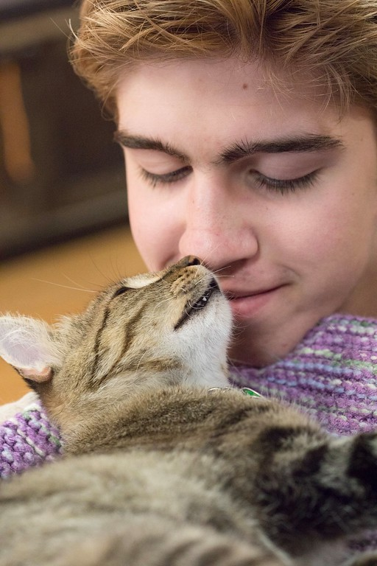
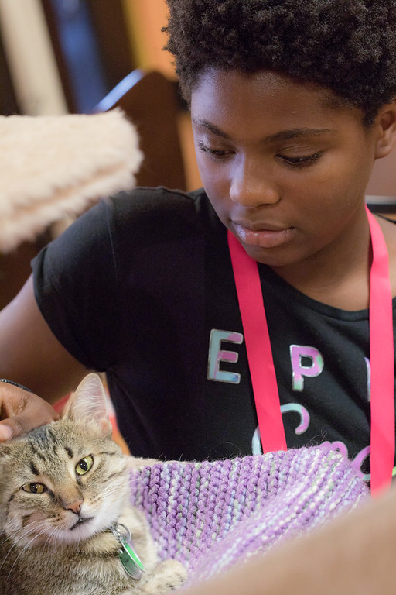
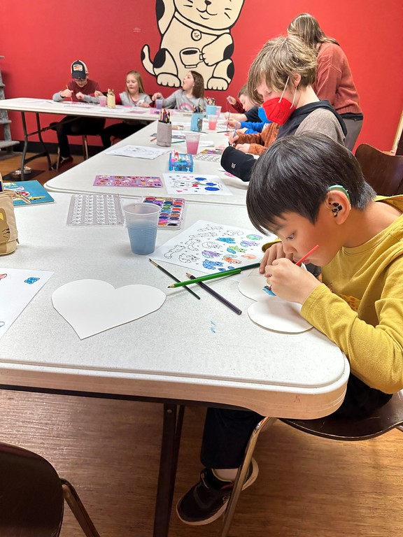
Camp Programs Handbook

Camp Contact Information
Phone: 734-661-3579
E-mail: humaneed@hshv.org
Address: 5245 Jackson Rd.
Ann Arbor, MI 48103

Welcome
Camp Purrs is a fun half-day camp for cat lovers! Each day, campers will play games, make crafts (including enrichment for our cats), participate in interactive educational activities, and, of course, spend time with cats.

What to Know Before Camp Registration
Registration
Registration for Camp Purrs is done completely online. We are not able to process registrations in-person or over the phone. Every week of Camp Purrs will be the same programming, so we ask that you do not sign your child up for more than one week.
If you make any errors or forget to include any information on the registration form, you can contact our team at humaneed@hshv.org with any corrections.
Waitlist
Families can add their name for any week(s) that they desire. If a space becomes available, all families on the waitlist for that week will be notified and the space will be filled on a first come, first serve basis via email. Due to time constraints, we will no longer be contacting families individually when openings arise.
Scholarships
A limited number of scholarships for Camp Purrs summer programs are available for families who are in financial need and would not otherwise be able to attend. Applications should be filled out and submitted online. To learn more or to fill out an application, visit our website.
Cancellation Policy
Summer Camp Purrs: If a cancellation is made prior to May 1st, a refund will be given less a $50 non refundable deposit, per participant. For cancellations after May 1st, no refunds will be given.

School Year Camp Purrs: If a cancellation is made prior to 60 days before the start of a camp, a refund will be given less a $50 non refundable deposit, per participant. For cancellations less than 60 days, no refunds will be given.
We’re sorry, we are not able to waive our policy for any reason nor are we able to have a child’s sibling or friend attend in your child’s place. Please email humaneed@hshv.org to request a cancelation if needed.
Age Groups
We want all camp participants to have activities and lessons that are fun and appropriate for them. For this reason, we designate our weeks of camp for specific age ranges.
For summer Camp Purrs, we base registration on the grade the child will be entering in the fall. Because our programming is designed for the specific age group, we ask that all participants register for their designated weeks. At this time, we do not make exceptions to the grade level designations.
For school year camps, all ages are grouped into one camp. These camps are open to children in 3rd-5th grade.
Allergy Statement
Tiny Lions Lounge and Adoption Center houses cats, and, therefore, cat fur, dander, and other potential allergens are present in the facility. There may also be other allergens present in Tiny Lions, such as shellfish, peanut butter, and dairy.
Special Needs
We ask parents/guardians to share information regarding special education needs their child may have during registration. Camp staff may contact you to discuss any accommodations your child may need to have a safe and happy experience! We, unfortunately, are not able to provide one-on-one support to Camp Purrs participants. If your child would benefit from a support person/aide to be successful at Camp Purrs, please let us know during registration! Support person must be provided by the family and be 21 or older.

What to Know for Camp
Staff
All staff and volunteers involved in our programming have a full background check and go through training on safety and health procedures. All camp staff members are CPR/First Aid certified.
Communication
Communication between camp staff and parents will primarily happen via e-mail. This year we will also be using the Class Dojo platform to post camp information (such as schedule, forms, etc.) and pictures from the day’s activities. Parents/guardians are under no obligation to download or use the Class Dojo app.
During the camp day, the best way to reach staff is by calling 734-661-3579.
What to Wear

Please send your child to camp in attire appropriate for play and animal interaction. We don’t recommend wearing anything that you or your camper will mind potentially getting dirty! We also recommend wearing pants or other clothing that covers the legs. Bare legs can easily be scratched by kittens!
It is highly recommended that campers wear closed-toe shoes for their safety.

Snacks and Water Bottles
Camp Purrs will provide a small snack to campers every morning. Snacks provided by Camp Purrs are always vegetarian. A list of the week’s snacks can be found on Bloomz or by asking camp staff. Campers are welcome to bring their own snacks if the ones provided aren’t to their liking.
We highly encourage sending your camper with a water bottle every day.

We do not eat lunch during Camp Purrs.

Drop-Off and Pick-Up

Doors for Camp Purrs will open 10 minutes before the start of camp (usually at 8:20 am). To ensure our staff has time to prepare for the fun day of camp, those

who arrive prior to that will kindly be asked to wait in the vestibule area. Please do not drop off children without checking in with camp staff. At drop-off, staff will ask for the name of the person who will be picking up. If the person who will be picking up changes, please contact us to let us know! Campers will not be released to any person whose name was not given to staff at drop-off or listed in the camper’s emergency contacts. Photo ID may be required for verification at pick-up.

All camp participants are to be picked up promptly at 11:30 a.m. Participants are not able to remain at Tiny Lions unaccompanied after camp hours. Campers picked up more than 10 minutes after the end of camp will be charged a late fee. If you and your child would like to stay at Tiny Lions after camp, we recommend making a reservation.

Medication
If a child will be bringing medications to camp with them, we require that a Medication Release Form is brought on the first day of camp. This form is required for both prescription and over the counter medications. When a prescription medication is brought to camp, the form must also include a doctor’s signature. We’re sorry – for your child’s safety we will be unable to administer medications without a completed form. Medications will be kept in a secure place by camp staff.
Staff will not provide any basic medications like pain relivers, antibiotic ointments, etc. to a camper without a Medication Release Form or express consent from a parent/guardian.

Camper Safety Expectations
Camp Purrs participants are expected to display safe, respectful and appropriate behavior at all times towards staff, volunteers, guests, other camp participants and animals. Behavior guidelines and expectations will be reviewed with camp participants on the first day of camp. At Camp Purrs we ask children to follow the STAR model:
Safe Choices: Make choices that keep you and others safe.
Teamwork: Share and participate in activities with others.
Ask Questions: Who, what, where, why, how, and beyond!
Respectful: Respect yourself, others, nature, and our shelter.
If a camper is unable to abide by these expectations, HSHV staff will assist in the following ways:
- Staff will talk with the camper and offer alternative, positive choices.
- If the camper needs to decompress, staff will offer the camper a break and, if needed, the chance to use some of the tools in the “calm down box.”
- If a camper continues to not abide by STAR expectations, staff will contact camper’s parent/guardian for support. Together we will determine next steps.
If a camp participant is consistently unable to abide by camp expectations and guidelines, they may be dismissed from Camp Purrs for the day or for the remainder of the camp session. Occasionally it may be determined that the camper may continue with Camp Purrs with the help of a support person (provided by the camper’s family). HSHV reserves the right to deny participation to any camper who exhibits unsafe behavior with staff, camp participants or animals at any time.

Illness
We follow the guidelines used by Ann Arbor Public Schools for keeping a child home due to illness. If your camper is displaying symptoms of a contagious illness or condition, we kindly ask that you keep them home from camp for as long as they are exhibiting symptoms. If a camper becomes ill while at camp, staff will first attempt contact with parent/guardian. If unable to make contact with parent/guardian within 30 minutes, camp staff will contact emergency contacts. Please plan to pick up a sick child in a timely manner as we do not have a nurses’ office or other comfortable accommodation for campers who are not feeling well while they wait to be picked up.
Injuries
For minor injuries, such as cuts and scrapes, staff will encourage the child to wash the affected area with soap and water. Bandages will be provided if necessary. At pick-up, parent/guardian be notified of the injury and will receive an injury report.
For more serious injuries, appropriate first aid will be given and parent/guardian will be notified immediately. If staff are unable to make contact with parent/guardian, emergency contacts will be contacted.
In the case of a medical emergency, staff will call 911 and then contact parent/guardian.
Cat Visitation
Learning and practicing safe interaction with animals is an important part of the Camp Purrs experience, but visitation with cats is only a small part of the camp day. Cat visitation time during camp usually ranges from 30-60 minutes total.

Camp Purrs staff will go over guidelines for visiting with cats with campers before any interactions. Guidelines are in place to keep campers safe and make sure the cats are comfortable. These guidelines are:
- Pet cats gently.
- Sit in one place with cats; no carrying cats around the café.

- Do not chase cats; walking feet only, please!
- Use inside voices.
- Let hiding cats hide, let drinking cats drink, and let eating cats eat.
- Please don’t bother cats while they’re in the litter box.

While staff will always go over these guidelines with campers, parents/guardians can help by reiterating these guidelines at home. They aren’t just good guidelines for camp, they’re good guidelines for interacting with cats in general!

