Dog/Puppy Visitation Volunteer Duties
- Sign into VIC (please make sure cell phones are put away during your visits).
- Walk through Dog Town and Pups Alley and take a look at which animals are available and have a
JV Approved cage card.
- Decide which of the JV Approved dogs/puppies are ready for a visit.
  - Puppies First (4 months or younger)
  - Adult Dogs Last (4+months)
  - No “I have a cold” or “I just had surgery” cards
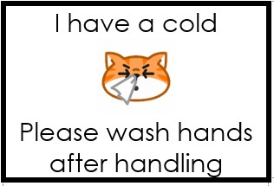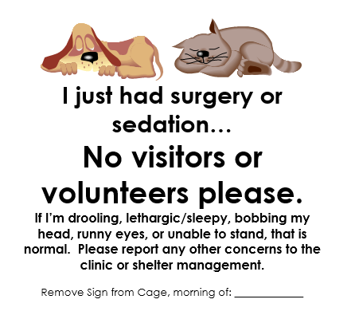
- Go to the Dog Walker station and read the JV Notes binder to see if there are any special notes about the dog/puppy you will be visiting with.
- Grab a clean towel from the dog laundry storage area. Make sure hands are sanitized.
- Visit with the dog for about 10-15 minutes. Observe body language to determine when to end your visit.
- Take your used towel to the laundry area.
- Sanitize your hands, arms and anywhere that the dog came into contact with (face, neck, etc).
- Record any behavioral information on that animal on the JV Dog Visitation Binder.

