Cat Comforting Volunteer Duties
- Sign into VIC (please make sure cell phones are put away during your visits)
- Take a walk through the cat hallways and decide where you would like to start comforting.
  - Kittens first (no “I have a cold” or “I just had surgery or sedation” cards.
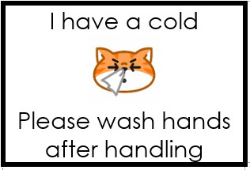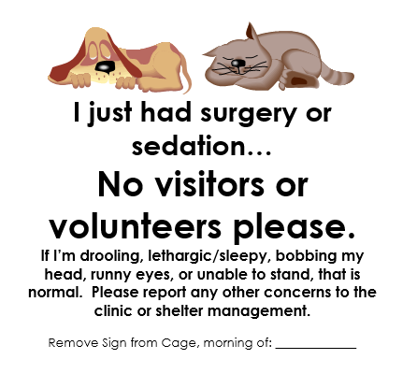
    - Kitten Lobby area (brown cages)
    - Kitten Room (directly across from cat kitchen)
  - Adult cats next. Adult cats MUST have a green JV approved card.
- For Uptown/Downtown/Condo cats, read the binders to see if there are any special notes about cats in any of these rooms.
- Gather a clean towel, sanitize your hands and begin visiting in your selected area.
- When your visit ends (no burrito wrapping adult cats, no cats/kittens in lap, sit with a burrito wrapped kitten), take your used towel to the laundry room.
- Sanitize your hands, arms and anywhere that the cat came into contact with you (face, neck, etc).
- Record any behavioral information on that animal in the appropriate binder (Uptown, Downtown, or Condo Cats only).

