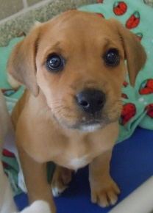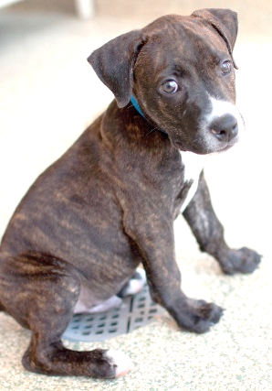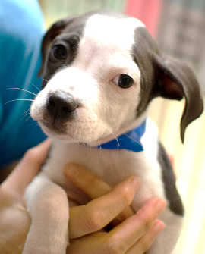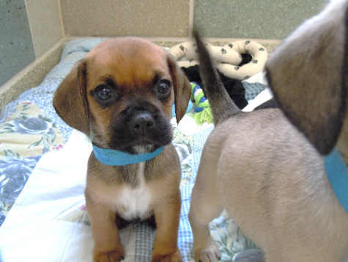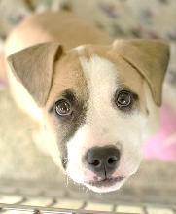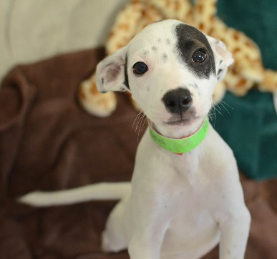

**Parvo Facts**

**What is Parvo?**

Parvo (parvovirus) is a highly contagious virus that can cause serious illness and sometimes be fatal. Parvo is a very strong virus and can remain in the environment for a long time without proper disinfection. The “incubation period” can be from 3 to 10 days from the time of exposure. While there is no cure, swift and aggressive therapies of supportive care can be highly effective and successful!

**How does it spread?**

Parvo is spread dog to dog through feces or anything that has been contaminated with feces such as hands, clothing, food bowls, toys, etc.

**Can people or cats catch Parvo?**

People cannot catch Parvo. Parvo disease in cats is known as Panleukopenia, often called “distemper”. Panleuk/distemper is a parvovirus, closely related to canine parvovirus. Unvaccinated or immune compromised kittens/cats are susceptible to parvo.

**What about other dogs or puppies?**

All dogs and puppies should be vaccinated against Parvo. Puppies must receive a series of vaccines to be fully protected and are the most vulnerable to catching this disease and becoming seriously ill. Unvaccinated adult dogs can catch Parvo, but may be symptom-free or show less severe symptoms unless old or immune compromised.

**Why doesn’t HSHV test all puppies for Parvo?**

Unfortunately the test for Parvo will not reliably show a positive result until the dog is already showing clinical signs of illness.  If we test a dog that appears healthy but has actually contracted the virus, the test will most likely show a false-negative – giving a false sense of security.

**What about my new puppy?**

All dogs and puppies adopted from HSHV have been initially vaccinated, but puppies must receive a series of vaccines to be fully protected. A series of 3-4 vaccinations before the age of 16 weeks is recommended. Seemingly healthy puppies can be adopted out, but become sick a few days after adoption. Parvo is a medical emergency. Immediate veterinary care is crucial.

It is very important to protect your puppy from exposure to sick, unknown or unvaccinated animals that you may come across in public spaces, until they are fully vaccinated. Keep your puppy off pet store, veterinarian office or other public floors. Good nutrition, exercise and low stress are always an important part of keeping your pets healthy.

The most common signs of this disease are vomiting, foul-smelling often bloody diarrhea, loss of appetite, fever, weakness, lethargy and dehydration. If any of these clinical signs are observed, seek medical care immediately. Early detection and treatment is crucial for survival.

**If your puppy shows signs of illness**, please contact HSHV’s Veterinary Clinic at

(734) 662-4365, or outside our Clinic hours: Emergency Veterinary Hospital at 734-369-6446

**3100 Cherry Hill Road | Ann Arbor, Michigan 48105 | (734) 662-5585 | www.hshv.org**

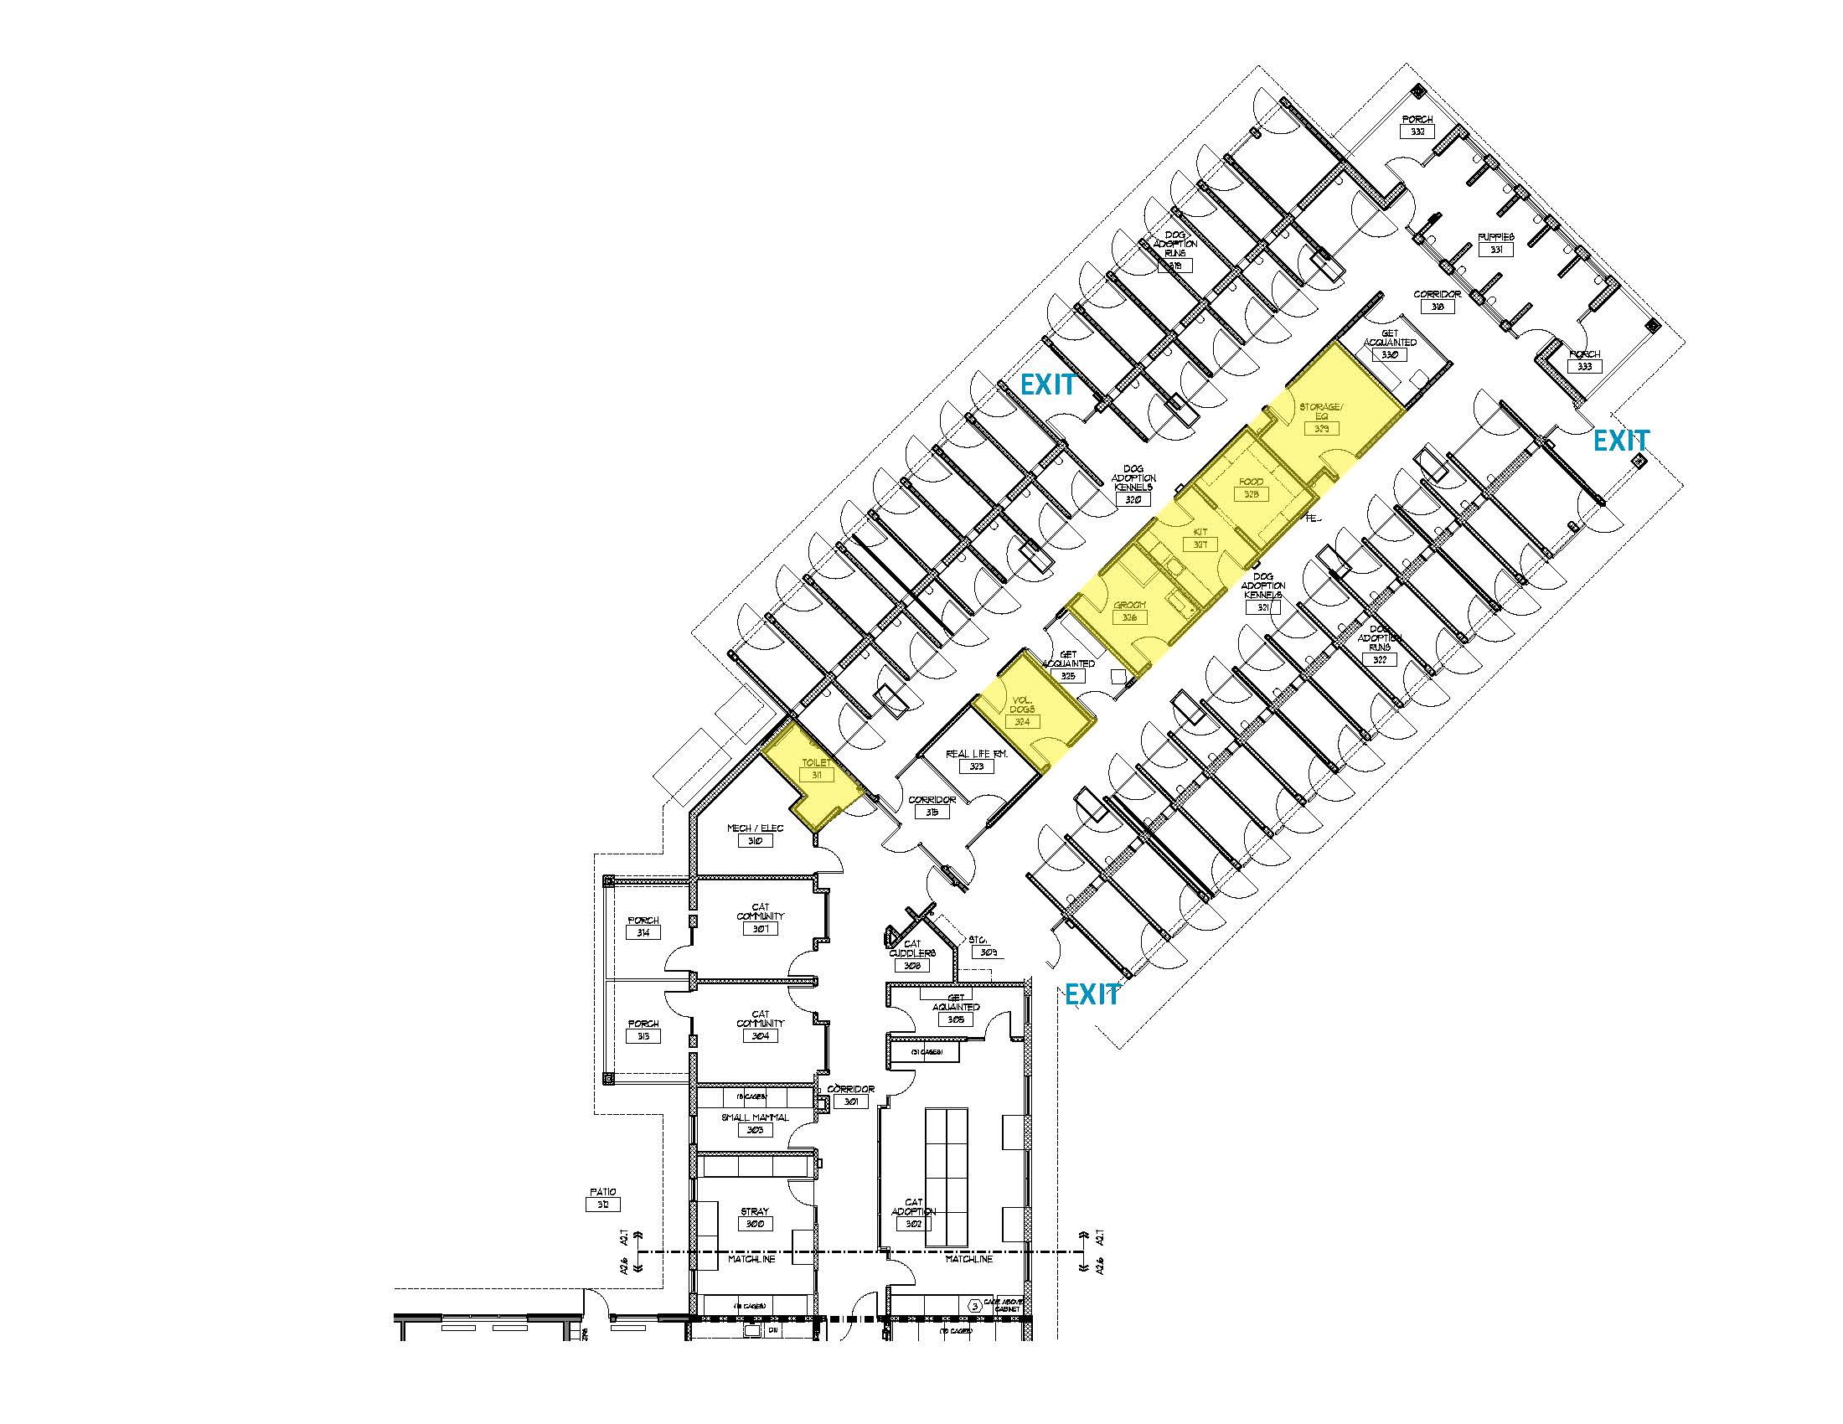

**Love Train Arrival**

**Kennel-Route Map**

**PUP**

**Puppy Room**

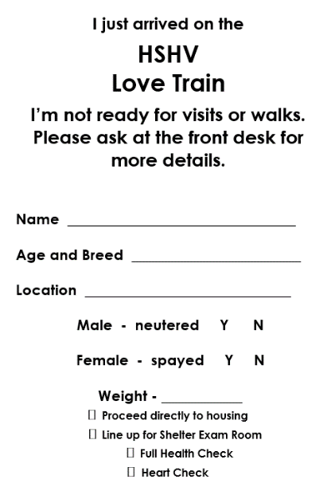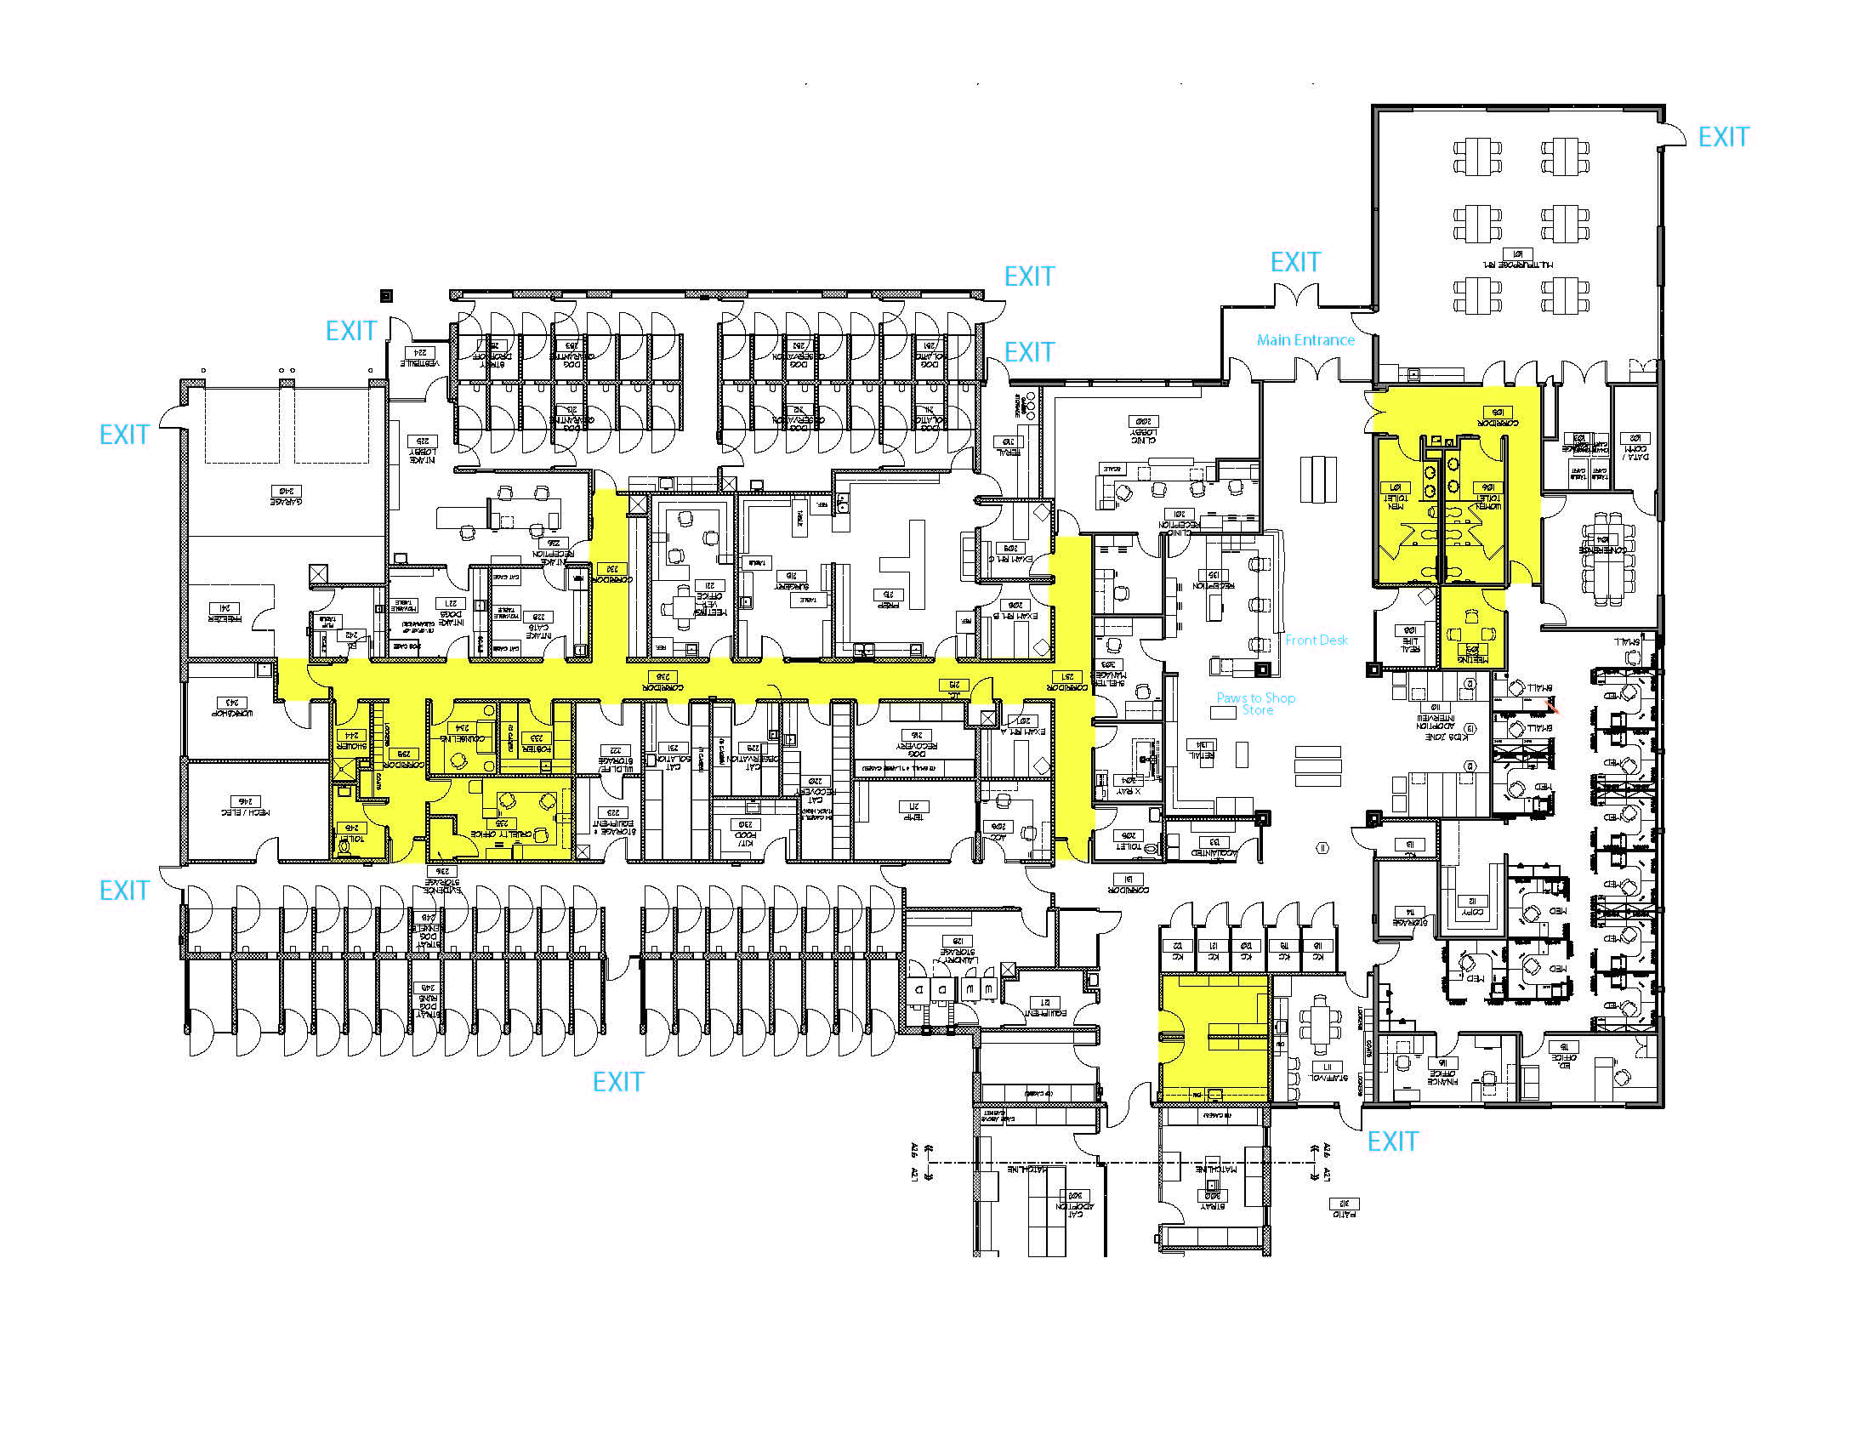

**PVR**

**Pup Visit**

**RL**

**Real Life**

**Intake**

**Entrance**

**★ Start HERE**

**After your dog’s exam, proceed to the location and kennel# as indicated on your cage card.**

**EC**

**Ed Center**

**GR**

**Groom**

**Dog Holding**

**DH 30-49**

**Dog IOQ**

**Clinic & Surgery**

**Dog Adoption**

**DA 1-14**

**DA 29-15**

**Adopt Front Desk**

**Dog Exam Rm**

**TT**

**Temp Test**

**Laundry Room**

**Main Entrance**

**Public Rest Rooms**

**Love Train FAQ’s**

**What is the Love Train?**

The Love Train is an animal transport initiative that brings animals from high-need shelters to HSHV. These animals are then lovingly cared for by our staff and volunteers, provided high quality medical care and then adopted to wonderful families through our adoption program.

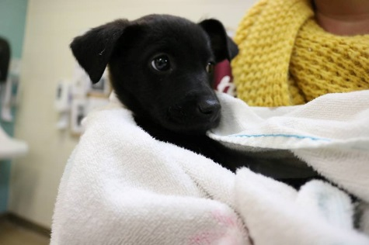

**Who arrives on the Love Train?**

The animals that we transport are mostly puppies, but we also transport adult dogs, adult cats, and kittens as space allows. (Our Cat Café, Tiny Lions Lounge and Adoption Center, has given us space to take in and adopt out more homeless cats and kittens.)

**Where do the animals come from?**

Our regular puppy and kitten Love Train transports come from a few main sources: HARTT in Clifton, TN; Hardin County Animal Services in Savannah, TN; and Florence-Lauterdale Animal Services in Florence, AL.

We also partner with local shelters to take in dogs and cats from places like Detroit Animal Care and Control, Bay County Animal Control, and other Michigan shelters as they need us.

**Why doesn’t HSHV help more in-state dogs instead of taking them from out-of-state?**

HSHV transfers animals from out-of-state not only to help save lives, but also to encourage our community to adopt a homeless companion animal instead of buying one from a pet store or breeder. For a variety of reasons, the most common breed of dog in Michigan shelters, and the ones most in need of transfer in-state, are pit bull/mix type dogs. Of course a pit bull is not the best fit for every family and we still face many societal challenges to pit bull adoptions, such as 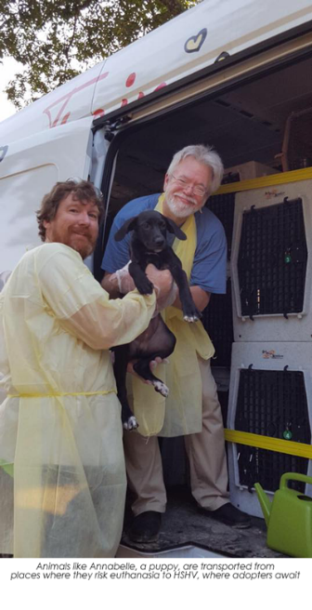breed restrictions and negative stereotypes. As such, HSHV always has many pit bull/mix type dogs from our own community waiting an extended length of time (often months) to be adopted. Bringing in dogs similar to those already waiting for homes just creates more competition for the same smaller percentage of adopting families which therefore creates longer wait times for those in our care and prevents us from being able to help other dogs in need because of kennels that turn-over much less often.

Working with a variety of source shelters both in and outside of Michigan allows the Love Train to provide different options for families who are looking for other breeds of animals and more specifically puppies (who only stay at our shelter for only 2-3 days before adoption and do not occupy traditional kennel space).

**How does the Love Train save lives?**

The Love Train saves lives in many ways. Many southern states struggle with a much higher level of pet overpopulation in part because of lower rates of pet sterilization. Because source shelters struggle with too many animals and not enough adopters, they desperately need help to avoid the euthanasia of healthy animals. The Love Train program not only saves the lives of unwanted animals who might otherwise be euthanized, it also gives hope and support to the people who work so tirelessly to save them.

In our community where spay/neuter rates are much higher and the number of stray animals is much lower, the Love Train also saves lives by giving families an alternative to buying a puppy from a pet store (where more than 90% are believed to come from cruel and inhumane puppy mills).

**How are the Love Train animals transported?**

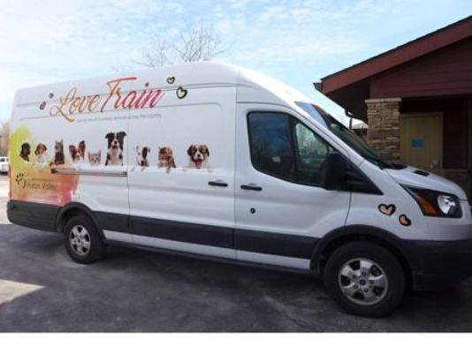 Thanks to a grant from PetSmart Charities and our generous donors, HSHV has its very own van loaded with crates that safely house the animals during transport. Our Intake Manager, Karie McMahon, manages our Love Train program and approves and coordinates all transports. We also have a part-time staff driver who who is responsible for picking up animals from the source shelters and bringing them to HSHV. Volunteers also play a vital role in Love Train transports by assisting as a passenger for the trips south and helping to safely and lovingly unload our new arrivals off the van.

**How many animals can safely ride in the vehicle?**

The number of animals we can transport depends on the size of the animals and whether they are single animals or litters of young animals. We follow best practice guidelines for transport housing -- advising that each animal must be able to lie down, stand up and turn around comfortably.

**What takes place during the intake process?**

When the Love Train arrives at HSHV, all animals are first unloaded from the truck and brought in through our Intake lobby. Cats and kittens are taken off the truck in carriers while dogs are either carried in a towel or walked on leash (depending on the size and age of the animal).

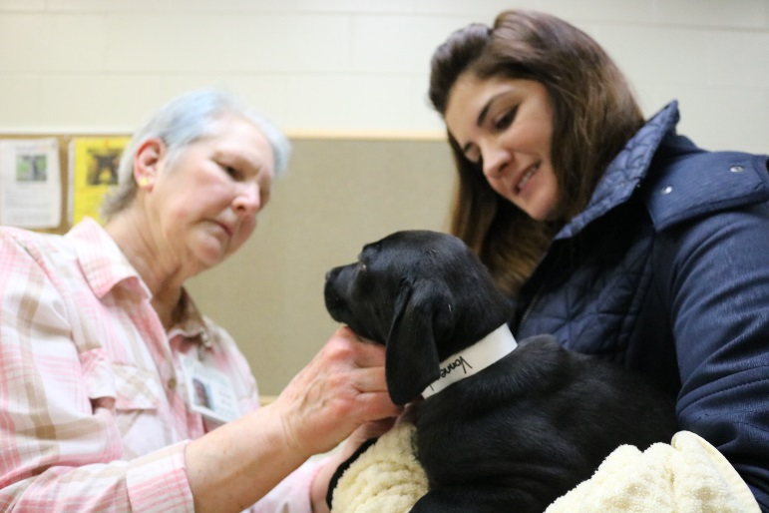 Once inside, Intake staff begin the check-in process. Some of these items may include putting a collar on the animal, taking their photograph for our records and scanning for a microchip. Intake technicians then give appropriate vaccines (based on species), dewormers (as appropriate for age/species) and weigh the animals. Also, if not already tested at the source shelter, cats who are transferred may get blood tested for FeLV (Feline Leukemia) upon arrival. Animals are then walked or carried to their housing space within HSHV.

**Where are animals housed within HSHV?**

Housing space is determined by our Behavior Team. Adult animals may be housed in general dog/cat housing areas. Additional rooms that can be used include puppy adoption, family visitation, the education center, and temperament test room. Young animals are typically housed together with all or some of their littermates. Once in their new housing spaces, animals then begin our process, including spay/neuter and any needed medical evaluation and treatment, to become available for adoption.

**Does Love Train take away resources from other animals?**

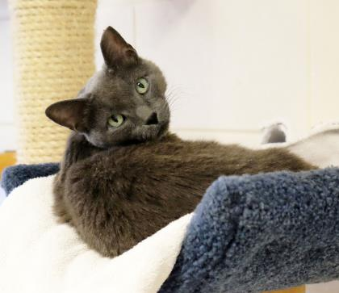 Love Train resources and traditional intake resources barely mix.  Love Train is its own funded department (with new funds, not taking from other departments) and has staff dedicated to its success.  Love Train work is a brief, albeit intense, job for Front of House/Adoptions, volunteers who take the pups off the truck and do adoptions, and our surgery/medical team.  The pups are mainly in temporary housing and do not compete for kennel space with the big dogs here. With so many adopters interested in puppies, most are adopted within 2-3 days.

In addition to saving many lives, any extra revenue generated from Love Train adoptions supports other animals in our care and helps pay for all the extra medical and behavioral treatment of our less immediately adoptable animals.  Extra revenue allows us to implement new practices -- for example, in 2017, we were able to add a behavioral/training consultant and work with a consultant on behavioral pharmaceutical treatment options for some of our higher needs animals.

It may also be helpful to know that in addition to monitoring individual animals, we review a long list of statistics every month. Because the dynamics of Love Train are so different, we separate those statistics out so that we can get the best sense of shelter trends, successes, challenges, and needs.

**Who adopts the animals?**

Adopters for Love Train animals come from many different communities – even out of state. HSHV typically requires adopters to be over the age of 21, but adopters over the age of 18 may also be considered.

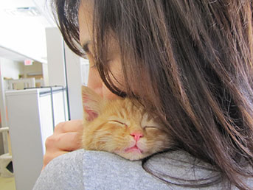**What is the process to adopt a Love Train animal?**

We are fortunate that many families are interested in adopting Love Train animals – especially our puppies. Due to the high demand of our dogs/puppies, HSHV has a numbering system in place for adopters. This allows visitation to be done on a first come/first serve basis and ensures that all families get equal time to see and visit with available animals. Because the Love Train does not typically take in large numbers of cats all at once, those interested in adopting a cat follow our usual adoption process and a numbering system is not needed. For more details on this process, please visit HSHV’s [adoption page.](http://www.hshv.org/site/PageNavigator/adoptions/info.html)

**What special considerations need to be made to prevent disease when handling and caring for a Love Train animal?**

Disease prevention and keeping animals and people safe and healthy is a top priority at HSHV. During the intake process and throughout their care here, all staff and volunteers who handle animals use clean towels for each animal and wear gloves that are changed between individual animals. Staff also follow strict cleaning protocols for all items used during their care to minimize exposure to disease. Used items are sometimes discarded when contanimated by highly contagious diseases.

Because some of the dogs and puppies that arrive on the Love Train may have come into contact with contagious disease, such as parvovirus and ringworm, extra care and caution is used while transporting and caring for these animals. Precautions such as double cleaning and the use of personal protective equipment may be taken.

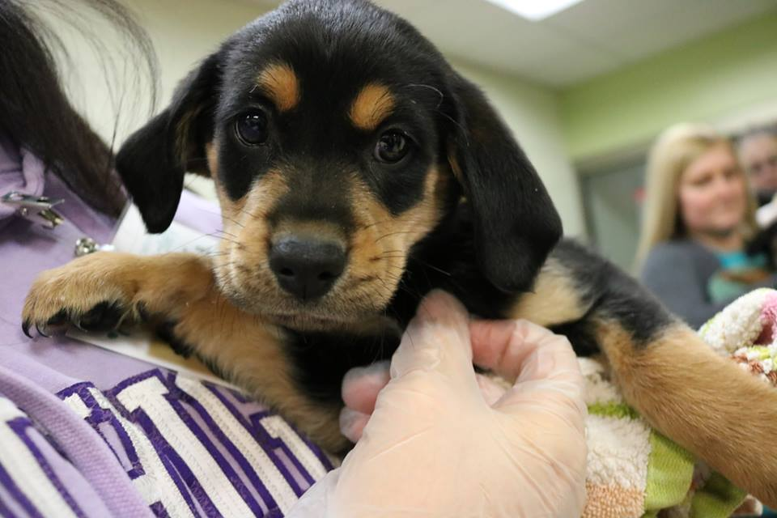**Why are Love Train puppies not treated for or tested for Parvovirus upon arrival?**

It is important to remember that only puppies actually showing symptoms of parvovirus are tested for parvovirus prior to adoption. We only test symptomatic dogs because the test for parvovirus has a high incidence of false negatives when used on animals without outward signs of illness. These false negatives allow people to incorrectly believe their puppy is disease free – which may cause a delay in treatment for this easily spread and potentally fatal disease. The incubation period for parvo is 3-10 days, which means the illness can show up after the animal has been adopted.

Therefore, adopters are given extensive information on parvovirus during three stages of the adoptions process – before/during visitation, at the front desk during adoption approval and during the adoption meeting. Information on parvovirus, the symptoms to look for and how to respond are also sent home with the adopter. Pet insurance is strongly recommended to all adopters and is provided through PetHealth (the same company that provides our shelter software and microchips). The insurance is free for 30 days and covers many conditions not previously diagnosed at the shelter. Emergency clinic contact information is also provided.

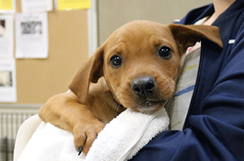**If there is the potential for disease such a Parvo, why aren’t puppies automatically quarantined for 10 days?**

The first few months of puppies’ lives are critical to their social development. With only a little over 5% of our Love Train puppies testing positive for parvovirus in 2017, quarantining beyond absolute necessity would be damaging to their social/emotional health. Understanding this critical need for socialization along with our low rates of parvovirus, we believe the safest and healthiest option is for HSHV to monitor puppies closely while in our care and ensure that adopters are properly educated on the risk, symptoms and treatment of parvovirus. We also use care to house littermates together while they are here and follow strict disease control protocols as mentioned above.

Quarantining all puppies would also unnecessarily take resources from the animals in our community. The Love Train transfers are for the most part healthy animals in high demand who have a short stay with HSHV before they are adopted. Keeping them here longer would require HSHV to divert many resources to their care that would otherwise go to homeless animals in our community. Further, the longer any animal stays at HSHV the higher the risk of them contracting other contagious or stress-related diseases. A loving home is always better than a shelter.

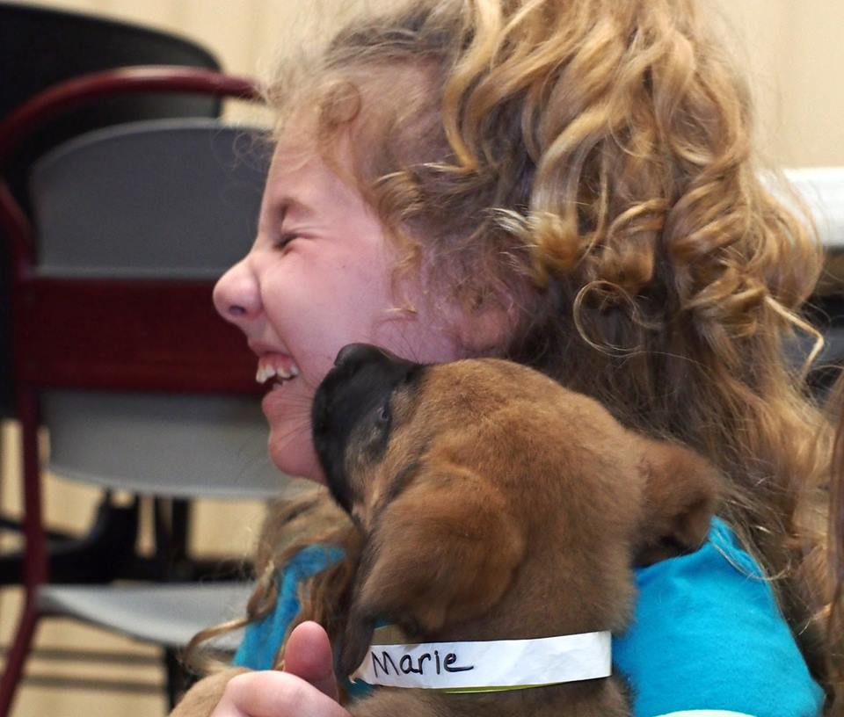**What post-adoptive care is offered?**

After any animal (Love Train or not) is adopted to a new family, our adoption team follows up with a post adoption survey. Adopters are also given the opportunity for discounted health exams through our HSHV clinic during the first 10 days after adopting an animal. Another great option for families at the time of adoption is to enroll in PetHealth insurance, which is free for the first month. Should an animal become ill with parvovirus, adopters are able to bring their animal to HSHV or an emergency vet hospital. In this case the fees for their treatment are paid for by HSHV.

**Why are volunteers so important to Love Train?** Like everything that we do at HSHV volunteers are critical to making Love Train a success! Your gift of time and love helps save hundreds of lives and creates so many happy families! **THANK YOU!**