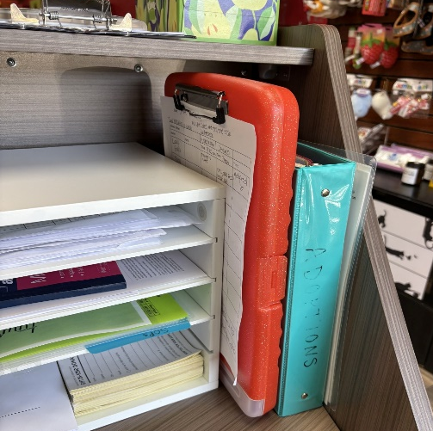
Wet Food Feeding How To

START:
- Wash your hands
STEPS:
- Grab the orange clipboard, which can be found at the front desk. The old and new food logs can be found inside the clipboard.
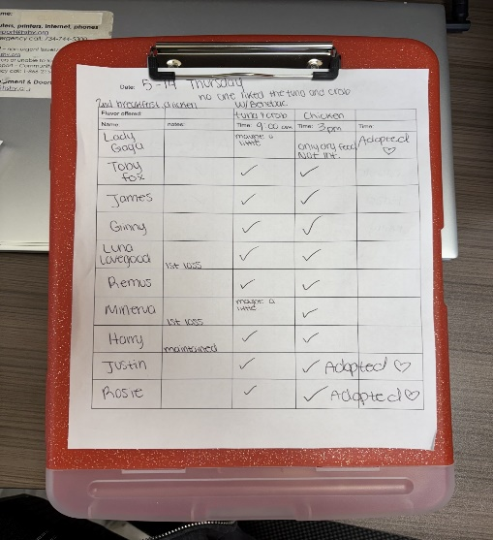
- Confirm that all the kittens and cats names are written down.
- Review notes if anyone has lost weight or needs proviable (probiotic) in their food. You can also ask a staff member.
- All feeding supplies can be found in the back room near the sink.

Gather:
- Metal mixing bowl
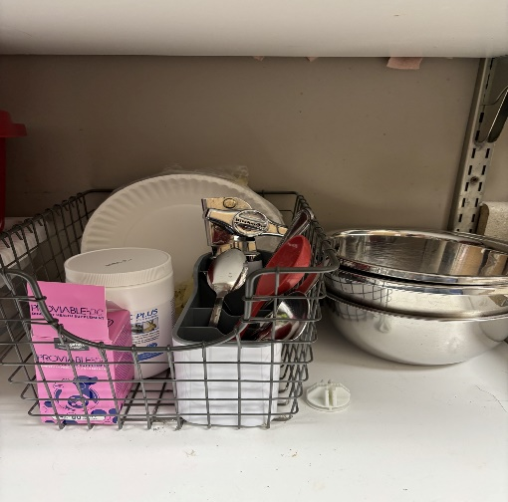
- A tray
- Enough plates for all cats and kittens
- Food textures and styles may be mixed together as long as the flavors are the same or similar… e.g., salmon pâté may be mixed with salmon shreds, broth, and salmon gravy varieties. Brands and textures do not need to match, but the flavors should.
- Small cans: 1 can per 2 cats/kittens
  - Large cans: 1 can per 4 cats/kittens
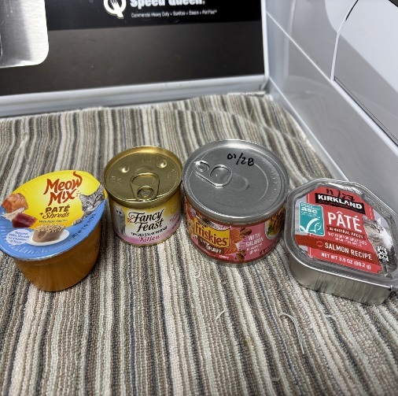
- Do not add water to food. Our goal is to encourage strong appetites, so offering food with the most smell and flavor helps make the meal more appealing to the cats and kittens, instead of watering it down.
- Gently combine the food in the large mixing bowl until just mixed. Do not overmix.
- Distribute the food evenly among all the plates.
- Distribute the plates to the cats and kittens. Multiple trips if necessar
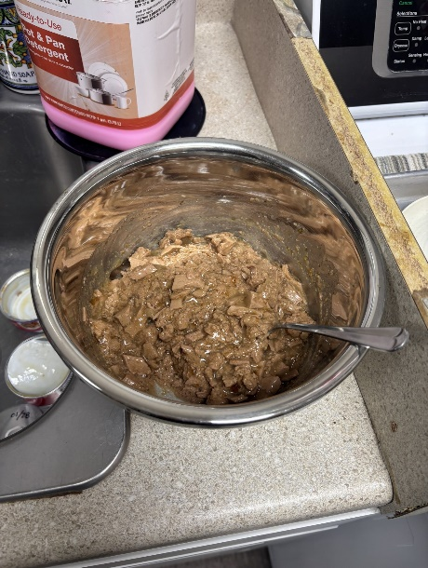
- Place each plate directly in front of the cat or kitten.
- It is okay to wake up the kittens for lunch. Sometimes they need a reminder that they are hungry.
- Navigating around customers can always be tricky, but feel free to explain that it’s lunch time and it’s important we let them eat.
- If you have a hard time locating a kitten or feeding the kittens around customers, don’t hesitate to grab a staff member for any further assistance.
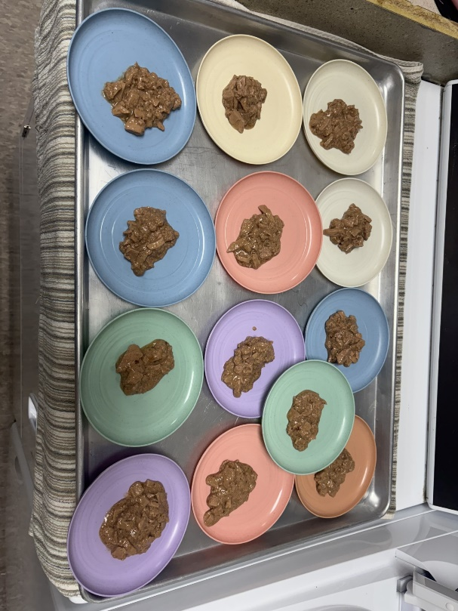
- You can also use an available room, such as the program room, office, or kitchen to put anyone that lost weight some extra space and time to focus on eating.
- After all food has been served, make several rounds to monitor everyone eating.
- Write a check mark or “some”, “most”, or “all” on the chart once you observe them eating.
- If a cat or kitten does not like the offered food, you can try a different flavor or texture directly from the can.
- Note any food preferences, concerns, or behaviors on the chart.
- Check that the dry food bowls are full, If not, please top them off from the bucket of food in the laundry room.
- Give yourself a big pat on the back for doing a great job helping our kitties!

END:
  - Return to the back room and rinse out the mixing bowl/utensils and add them to the grey dirty dish bin at the bottom of the dry food cart.
  - Rinse out cat food cans and place in recycle bin
  - Walk through the café, check water dishes, top off dry food as/if needed.
  - Wash your hands.

THANK YOU

