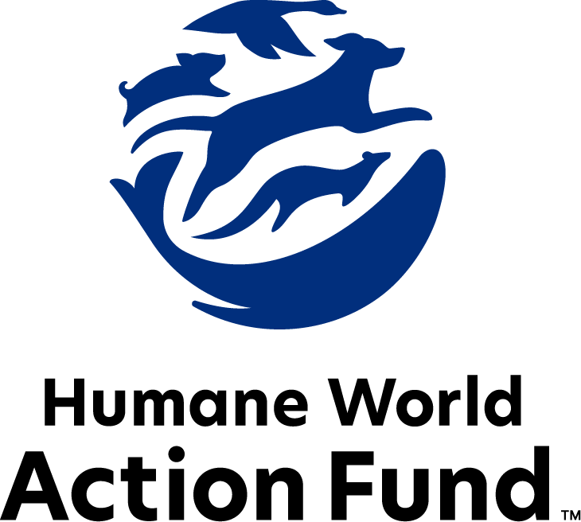

Formerly called
Humane Society Legislative Fund

CANDIDATE QUESTIONNAIRE
Michigan state office

2026 Michigan state office candidate questionnaire
Candidate Name: _Martin A Church______________________________________________________
Candidate Address: ______815 Young Ypsilanti, MI 48198
Office Sought: ___Michigan House ____ Locality: _____32 District_______
Staff Contact Name: __Martin Church Phone: ___734-834-4282_____
Email: ___Martin4MIhouse@Fathersed.org___ Website: __None__

Animals play an important role in the lives of many Americans. Countless citizens look to their local government to protect animals from cruel treatment and exploitation. Humane-minded individuals care deeply about the positions their elected officials take on animal protection issues.
For information on the range and details of our issue areas, please visit the websites of Humane World Action Fund (humaneaction.org) or Humane World for Animals (humaneworld.org).

Background information

What actions have you taken to promote the welfare of animals in the past? (Please include any action taken in an official or unofficial context.)
Leader Dog Puppy Raiser 5 years
Scout Leader (60 Years) introducing Young men to wild life and how to correctly interact with them safely

Are there any animal welfare programs or issues of importance to you that you would take initiative on after you are elected?
Correctly define what a service animal is vs a therapy or working dog. For instance, I see a lot of pets wearing signs that say they are a service animal which do not show proper training.

I also support the proper harvesting of animals in areas where the numbers are posing a danger to themselves and the local community. This would also include harvested animals being passed on to shelters to provide food for the homeless and food insecure families

Will you post information in your campaign materials stating your positions on animal protection issues?
If I had Materials yes, But as I am under funded I have none to post.

Do you have, or have you had in the past, any pets that have made an impact on you personally?
Yes, from a young age I have had several Dogs a couple of cats and a bird.
My Mom was one of the first Animal Technitions from Wayne State. So I have a number of interactions with different species of animals.
I also have been trained by the Detroit Zoo on how to teach animal interactions with Wild live.

STATE ISSUES:
Statewide office holders and members of state legislatures influence animal protection policy by supporting humane legislation, opposing government programs that use taxpayer funds to harm animals, supporting funding for government programs to protect animals and for adequate enforcement of animal welfare laws, and opposing inhumane laws or those which weaken current protections. We’d like to know your position on the following important animal welfare issues, which are subject to debate in your state.

PETS AND CRUELTY

Puppy Mills: Internet sales, flea markets, face-to-face sales and many pet stores that sell puppies are getting those dogs from puppy mills. A puppy mill is an inhumane, high-volume commercial dog breeding facility which churns out puppies for profit, ignoring the needs of the pups and their mothers. Dogs from puppy mills are often sick and unsocialized. Pet retailers often falsely assure consumers that the puppies they offer for sale are raised in reputable or humane breeding facilities, when really, they are coming from mass production puppy mills.

Will you support legislation to end the sale of puppies sourced from puppy mills in pet stores?

__X___ Yes _____ No _____ Not Sure

FARM PROTECTION AND FOOD SAFETY

Factory Farming: On factory farms, egg-laying hens are packed into battery cages where they can't even spread their wings. Baby calves are taken from their mothers and confined in pens so small they can barely move, and pigs are locked in gestation crates the width and length of their bodies, unable to even turn around. Michigan currently prohibits the use of gestation crates and veal crates and passed into law a ban on the production and sale of eggs from chickens locked in cruel cages, which took effect in 2025.

Will you oppose efforts to repeal laws which protect animals on farms in Michigan, or efforts to delay their implementation?

_____ Yes _____ No _X____ Not Sure

Fashion: Animals need their fur coats more than we do, and whether trapped in the wild or raised on farms, animals used in the fur industry suffer immensely. On fur factory farms in the U.S. and around the world, millions of rabbits, foxes, mink, and other wild animals spend their entire lives in cramped cages, deprived of the ability to engage in natural behaviors — only to be crudely gassed or electrocuted at the end. In the wild, animals are caught in crippling leghold traps without food or water, suffering for days before they die or are killed. Leghold traps are indiscriminate, often maiming and killing non-target animals, like threatened species and even pets—all this in the name of fashion. Prohibiting the sales of new fur products will support efforts to end this cruel industry, while still allowing businesses to sell vintage or used fur products, and continue services caring for fur products, such as storage and cleaning.

Will you support efforts to prohibit the sale of new products containing fur from animals?

_____ Yes _____ No __X___ Not Sure

RESEARCH, TESTING, AND FASHION

Cosmetics Testing: Humane and safe cosmetics can be made using the thousands of existing ingredients that have already been approved, and several non-animal safety tests are already available for new ingredients. These non-animal alternatives not only save countless animals, but can be cheaper, faster, and more relevant to human biology, and therefore more reliable at predicting safety. Countries with a collective 1.7 billion consumers, including India and those in the European Union, already prohibit the sale of cosmetics tested on animals, and global companies are meeting this demand with cruelty-free products. Eleven states in the U.S. prohibit the sale of new cosmetics products tested on animals, and it’s expected that more will consider legislation.

Will you support legislation which would prohibit the manufacture and sale of newly animal-tested cosmetics?

__X___ Yes _____ No _____ Not Sure

Queenie’s Law: Tens of thousands of dogs are used in research facilities in the U.S. each year, including in Michigan’s publicly funded research institutions. Public records show that Wayne State has conducted experiments on dogs that range from cutting open their chests to implanting medical devices in their arteries to running them on treadmills to heart failure. Queenie was one of these dogs who needlessly suffered and died in Wayne State’s laboratories. And despite conducting this type of testing since the 1990s, Wayne State has failed to demonstrate that these experiments benefit human patients while a number of humane alternatives exist that are better predictors of human health and safety. Queenie’s Law (SB 127) would prohibit painful dog experiments at Michigan’s publicly funded institutions, giving dogs like Queenie a chance at survival and ending the waste of taxpayer dollars on these outdated and cruel practices.

Will you support legislation like Queenie’s Law (SB 127) to end the cruelest animal experimentation practices in Michigan’s publicly funded research facilities?

_____ Yes _____ No _X____ Not Sure

WILDLIFE
Killing Contests: Wildlife killing contests are organized events in which participants compete for prizes to see who can kill the most or the largest animals within a certain time period. Most Americans are shocked to learn that thousands of animals – including coyotes, foxes, and bobcats – are killed in these events every year across the United States. Despite scientific evidence that shows that killing contests are ineffective at reducing carnivore populations, and a statewide prohibition on predator bounties, Michigan hosts dozens of killing contests every year.

Will you support legislation to address killing contests by making it unlawful for any person to organize, sponsor, promote, conduct, or participate in a competitive event at which the participants harass or kill native carnivores?

___X__ Yes _____ No _____ Not Sure

Wolves: The Michigan Department of Natural Resources already provides the state’s ranchers with fencing, fladry (rope with flapping flags), and guard animals to protect livestock from native carnivores, and has stated that these methods are highly effective. Michigan livestock owners are also compensated for confirmed or even suspected losses to wolves. There have been zero documented incidents in which a wolf has posed a threat to human safety in the state of Michigan, and in 2024, data from the Department of Natural Resources indicate that only three of the 1,000 plus working livestock farms in the upper peninsula experienced conflicts with wolves. The state’s wolf population has remained stable across the upper peninsula for the past ten years.

Given the lack of scientific justification and overwhelming public opposition to wolf hunting in the state of Michigan, will you support legislation to remove wolves from the game species list and oppose legislation that encourages a hunting season for wolves?

_____ Yes _____ No _X____ Not Sure

Captive Wild Animal Performances: Decades of documented animal mistreatment and public health risks have greatly reduced the popularity of exhibitions that display or allow public contact with wild animals. Despite this, Michigan’s Large Carnivore Act has become progressively weaker, permitting the intentional breeding of animals for photo opportunities and relaxing standards for wild animal exhibitors.

Will you support legislation to strengthen Michigan’s Large Carnivore Act by banning the use of large carnivores, such as black bear cubs, for public contact?

_____ Yes _____ No __X___ Not Sure

Appointments to State Agencies: Michigan state agencies are responsible for a wide range of policymaking with immeasurable effects on the state’s animal populations and wildlife habitats. With much to gain, special interests often fill state commission seats—where there should instead be a diverse group of perspectives, representing the broad interests of the public.

Will you encourage the appointment of a diverse range of experts committed to preserving Michigan’s natural beauty and wildlife, backed by science and not by special interests?

_____ Yes _____ No ___X__ Not Sure

My support or opposition of these Laws will be based upon what is in the proposed Legislation. Your questions were based upon some biased concepts which should be fully debated. I support humaine treatment of animals but also support harvesting of animals to prevent the spread of Disease and destruction of farms.

Thank you for your time! Please return the completed questionnaire to:

Humane World Action Fund
1255 23rd St NW, Suite 455
Washington, D.C. 20037
Phone: (202) 676-2314

Email: info@humaneaction.org

Rev. 1/28/2026
© 2025 Humane World Action Fund

About us
We fight for political and policy change to tackle the root causes of animal cruelty and suffering.
We work to advance our mission by
passing animal protection laws at the state and federal levels, educating the public about animal protection issues and supporting humane candidates for office. Together, we act to end animal cruelty.

humaneaction.org

